PeopleSoft (HR) Self Service-available to All Employees
Navigate to Holycross.edu>Faculty & Staff>Employee Resources>Human Resources(HR) Self Service
Enter network Username and Password>Click the My Paid Time Off tile> Accrual balances appear at the top of the page.

Kronos-Time Entry –Available to a limited group of employees
Navigate to Holycross.edu>Faculty & Staff>Employee Resources>Kronos-Time Entry
Enter network Username and Password>If you are not a time card approver the following page appears.
*Timecard approvers need to locate their timecard and open.
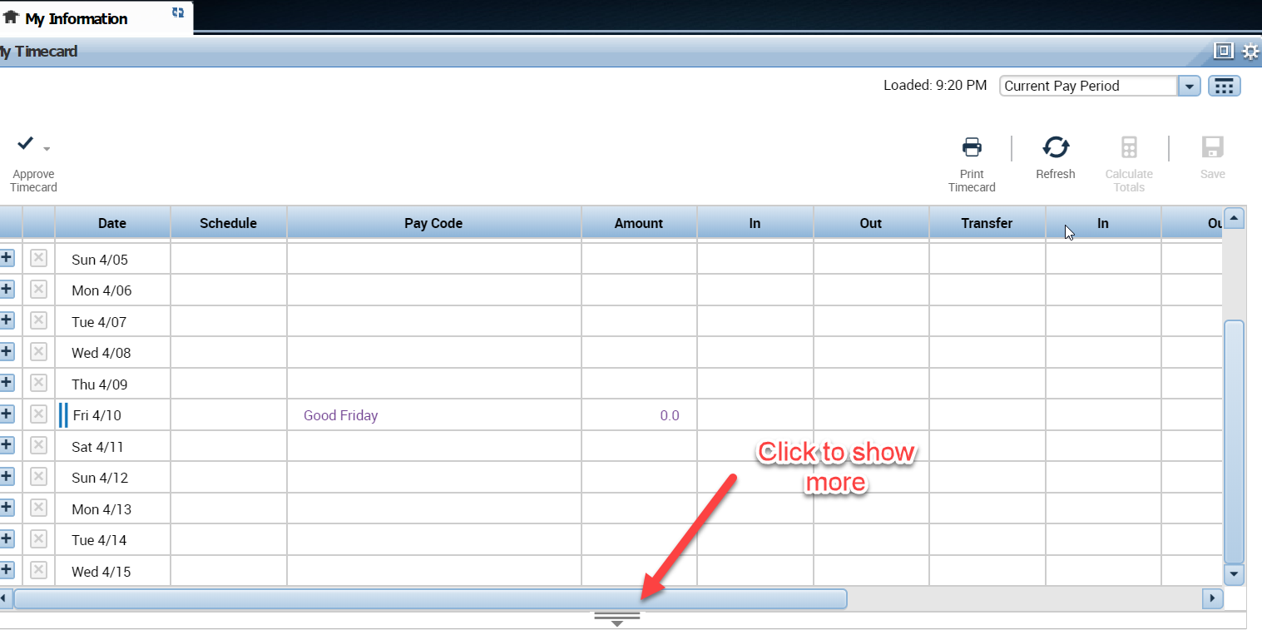
Click to show more>Slide this line up> Select the Accrual Tab, the following will appear.
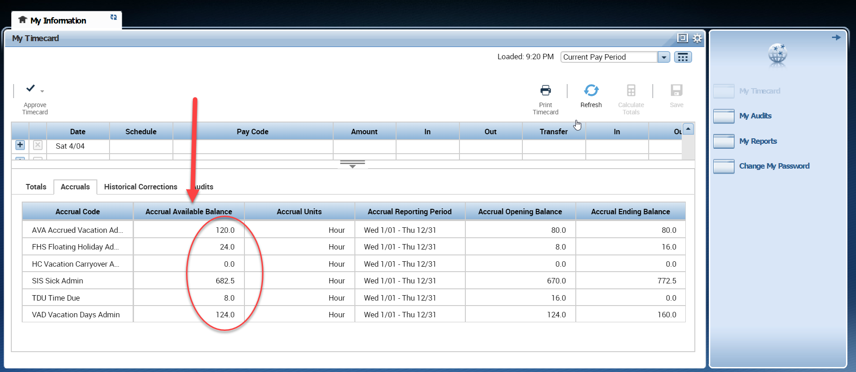
Available accruals are in the 2nd column, ignore everything to the right.

