College of the Holy Cross, Worcester, Massachusetts

College Honors Program

&

Department of Economics and Accounting Honors Program

Broadway Theatre and the COVID-19 Pandemic:

How Pre-Shutdown Longevity Impacted Production Success

Emmeline A. Lignowski, 2024

Thesis Advisor: Melissa Boyle

Thesis Reader: Robert Baumann

1. **Introduction**

On March 12, 2020, the forty-one Broadway theaters in New York City halted performances due to the COVID-19 pandemic. For a year and a half, Broadway was dark, finally reopening in August 2021 for the 2021-2022 season. Prior to the pandemic, many of Broadway’s longest running productions were landmarks in their own right, attracting tourists from around the world with help from their well-known names and recognizable posters. During the shutdown, however, the world witnessed great social change and rising inflation catalyzed by the pandemic. Upon Broadway’s reopening, “all productions, new and old, basically re-started from zero” meaning that “formerly reliable warhorses were competing with new shows” (Goldstein 2022). While new productions faced challenges establishing themselves on the Broadway stage, in the midst of a global pandemic no less, old productions that had once been reliable standards struggled to recoup losses, and all productions struggled to combat the added pressures of the pandemic.

Even after theaters re-opened their doors, COVID-19 outbreaks among cast and crew caused performances to be canceled. This uncertainty, compounded with other factors, caused potential consumers to hesitate when considering whether to see a production. Poor economic circumstances discouraged people from spending money on tickets. Travel restrictions prevented distant audiences, especially international tourists, from visiting New York. Many potential theater goers feared contracting COVID-19, while others preferred to wait until restrictions, such as mask mandates, were lifted, so that they could better enjoy the performance (Goldstein 2022; Pisani 2022).

As theaters lifted restrictions and the world grappled with the fact that COVID-19 is here to stay, Broadway continued to feel the pandemic’s devastating effects. Understanding the role of longevity is crucial in an industry where many productions have open-ended runs without a predetermined closing date. Though in the past, long-running productions may have been consistent streams of income for theater owners and stable employment for cast and crew, the events of the COVID-19 pandemic have suggested that productions cannot rely on their longevity alone. Notably, Broadway’s longest running production, *The Phantom of the Opera*, announced its closure and held its final performance in April 2023 after thirty-five years and over 13,000 performances. Such events beg the question: *how does the longevity of Broadway productions impact their ability to overcome economic shocks, in this case a devastating recession caused by a global pandemic?*

2. Literature Review

The economics literature pertaining to Broadway theater is relatively small, and because of its recency, research regarding the COVID-19 pandemic’s impact on Broadway theater is even more scarce.

Several previous studies have examined ticket pricing for Broadway productions and sectors of arts and entertainment. Tying into the “time inconsistency conjecture” of Coase (1972), it has been found that firms have an incentive to lower prices when demand begins to taper off; in addition, there is little price variation in repeated performances (Courty, 2000). A case study on the 1996 Broadway production of *Seven Guitars* examined price discrimination due to discounts and how ticket prices varied across different seat qualities and performance times (i.e. weekday versus weekend; or matinee versus evening) (Leslie, 2004). More recently, it has been found that incumbent Broadway productions lower their ticket prices when a new production enters the market. This practice is most likely to compete with the novelty and excitement that is associated with new productions (Jaworski et al., 2018).

Previous studies have also examined factors that influence the longevity and success of Broadway productions. A stochastic dominance approach has been used to investigate whether there are too many revivals on Broadway. A “revival” is a new production of an old show that has already been on Broadway. While revivals might not necessarily have longevity in terms of continuous performances, they provide familiarity to audiences, similar to long running productions. Further, some investors might consider revivals of previously successful shows to be financially safer than taking a chance on a completely new show. While it may be difficult to argue that there are “too many” revivals, through the stochastic dominance approach, it was found that revivals make up an increasing proportion of new productions, possibly because audiences increasingly preferred familiarity or because investors increasingly preferred perceived safety (Maddison, 2005).

It has been found that ticket prices have no significant effect on longevity and that other factors, such as critics’ reviews and advertising are more likely to impact how long a production remains open. Further, longevity was also found to have a positive impact on production success (Reddy et al., 1998). Through the use of a Cox proportional hazards model, another study found that critics’ reviews, specifically from *Daily News,* are related to longevity. In addition, being a musical and winning a Tony Award are both expected to increase longevity, while being a revival production and being nominated for a Tony Award but losing are both expected to negatively affect longevity (Nygren and Simonoff, 2007). Through a discrete choice model, it has been found that winning a Tony Award is expected to increase a production’s profits by 12%. In addition, being nominated for a Tony Award is expected to increase a production’s profits in the weeks following the nomination announcement, however, being nominated and not winning the award can decrease profits. Further, the effects of the Tony Awards could be delayed by as much as a year (Boyle and Chiou, 2009).

It has also been found that the presence of celebrities in Broadway productions can impact success. For example, a case study measured the musical *American Idiot* was impacted when Green Day lead singer Billie Joe Armstrong joined the cast. This study did not find any statistically significant differences in gross between the weeks that Armstrong performed and weeks where he did not (Maclean, 2021). Another study, however, found that weeks with a celebrity performance are expected to see an increase in gross of approximately $250,000. Celebrity status was determined using the IMDb “STARmeter” which uses volume of searches to measure stardom (Maclean and Ødegaard, 2022).

These studies pertaining to factors that impact longevity and success will be particularly relevant to my own research since I hope to gain a better understanding of how longevity and success are related. My paper will differ from these previous studies in that I will use longevity itself as my main independent variable of interest and use other previously determined factors of success, such as being a revival or winning a Tony Award, as control variables. Further, because of the recency of the COVID-19 pandemic, I am among the first to study the economic impact of the pandemic on Broadway theater, and especially how productions’ pre-shutdown longevity impacted their ability to recover from the recession caused by the pandemic.

3. Data

This study uses panel data compiled from four sources: Playbill, the Internet Broadway Database (IBDB), Broadway World, and the website for the Tony Awards. Five measures of weekly production success were identified: gross, average ticket price, top ticket price, attendance, and ratio of seats that were filled compared to a theater’s full weekly capacity, referred to as “percent capacity.” Data for all five measures of success were collected on a weekly basis. The dataset begins with the week ending in May 29th, 2016, which is the beginning of the 2016-2017 season, and ends with the week ending in September 17th, 2023, which was present day when the data were being compiled. All data measured in currency, such as grosses and ticket prices, were converted to September 2023 USD.

A binary variable *pre_shutdown* was created to divide the data into pre-COVID shutdown and post-COVID shutdown periods. Specifically, *pre_shutdown*=1 if an observation occurred in a week before the shutdown. Otherwise, *pre_shutdown*=0. The pre-shutdown period (*pre_shutdown*=1) begins with the week ending in May 29th, 2016 (the beginning of the dataset) and ends with the week ending in March 8, 2020 (the last week of available data before the shutdown). The post-shutdown period (*pre_shutdown*=0) begins with the week ending in August 8, 2021 (the first week of available data after Broaday reopened) and ends with the week ending in September 17, 2023 (the end of the dataset).

Two variables were used to measure productions’ pre-shutdown longevity. First, the 0/1 binary variable *old* was created to divide the data into productions that were open before the shutdown and productions that were new after the shutdown. Specifically, *old*=1 is a time-invariant indicator of whether a production was running before the shutdown.[1] If a production was new after the shutdown, *old*=0. (Productions that are *old*=0 are also frequently referred to as “new” in this study). The second measure of pre-shutdown longevity is the number of pre-shutdown performances, denoted as the continuous variable *num_pre_perf*. For productions that were only open after the shutdown, *num_pre_perf*=0. While the variable *old* more easily divides the data, *num_pre_perf* allows for greater differentiation within the *old*=1 group. For example, *The Phantom of the Opera* had been running for thirty years when Broadway shut down, while the play *The Lehman Trilogy* held its first preview on March 7, 2020, just days before Broadway shut down. Both would be considered *old*=1, however, they obviously have very different levels of pre-shutdown longevity.

Because of their geographic concentration, Broadway theaters make a good sampling pool because many things are naturally controlled for (Jaworski et al. 2018). This is especially important during the pandemic since COVID-19 restrictions and outbreaks are the same down to the local level. Each production is a unique product, however, and thus, the dataset also includes production characteristics, which were constant for all weeks that a particular production was open. Binary 0/1 variables were used to describe productions as musicals, plays, revivals, limited runs, and whether or not the production was performed in a theater run by a non-profit organization.[2] The variable *other*=1 if a production is neither a musical nor a play, and *other*=0 if otherwise. Examples of productions in the *other*=1 category would be concerts, comedy shows, or magic spectacles.

Two additional 0/1 binary variables were also created to control for whether a production won or was nominated for a Tony Award, which is the highest recognition of achievement in Broadway theater. The variable *tony_win*=1 if a production won a Tony Award in one of four categories: Best Musical, Best Play, Best Revival of a Musical, or Best Revival of a Play. Otherwise, *tony_win*=0. The variable *tony_nom*=1 if a production was nominated for a Tony Award in one of four categories: Best Musical, Best Play, Best Revival of a Musical, or Best Revival of a Play. Otherwise, *tony_nom*=0. If a production won a Tony Award, it will be both *tony_won*=1 and *tony_nom*=1.[3]

## Summary Statistics

Since production characteristics and outcomes may differ pre- and post-COVID, summary statistics are presented separately for the periods before and after the shutdown. Table 1A presents the summary statistics for the pre-shutdown period. Table 1B presents the summary statistics for the post-shutdown period.[4] The variables *gross_2023, avg_tix_price_2023,* and *top_tix_price_2023* are inflation adjusted variables using September 2023 USD. One notable discrepancy between the two periods is that there are over twice as many observations in the pre-shutdown period compared to the post-shutdown period. Part of this is because the pre-shutdown period covered more time; in addition, in the post-shutdown period, productions re-opened at staggered dates, meaning that in the first few weeks of the post-shutdown period, there were only a few productions running, and thus, fewer observations for those weeks.

Another difference between the two periods is that all five measures of success (gross, attendance, percent capacity, average ticket price, and top ticket prices) are nominally higher before the shutdown. In addition, the post-shutdown period also appears to have more revivals and limited run productions. For all five measures of success the differences between the pre- and post-shutdown periods are statistically significant.

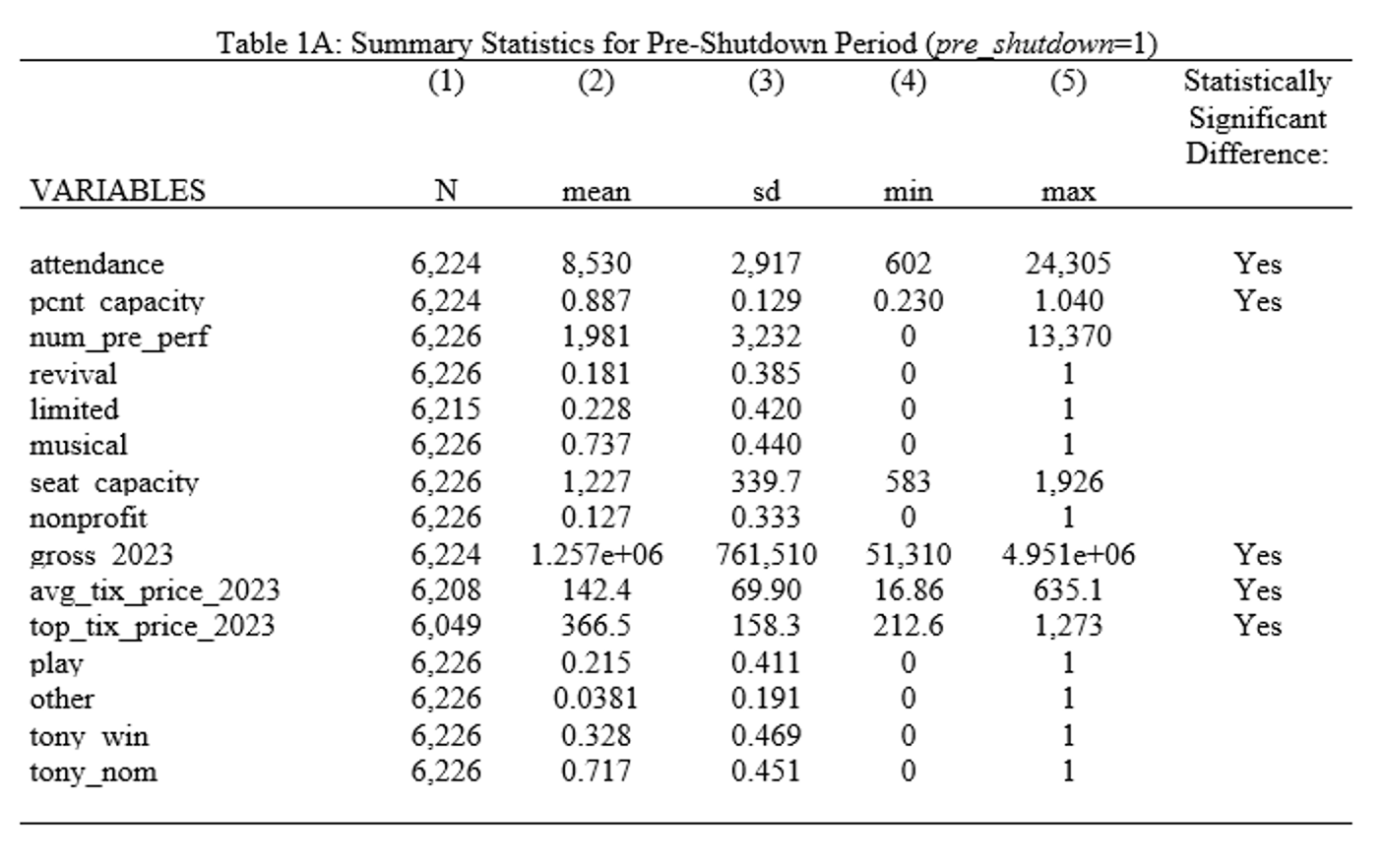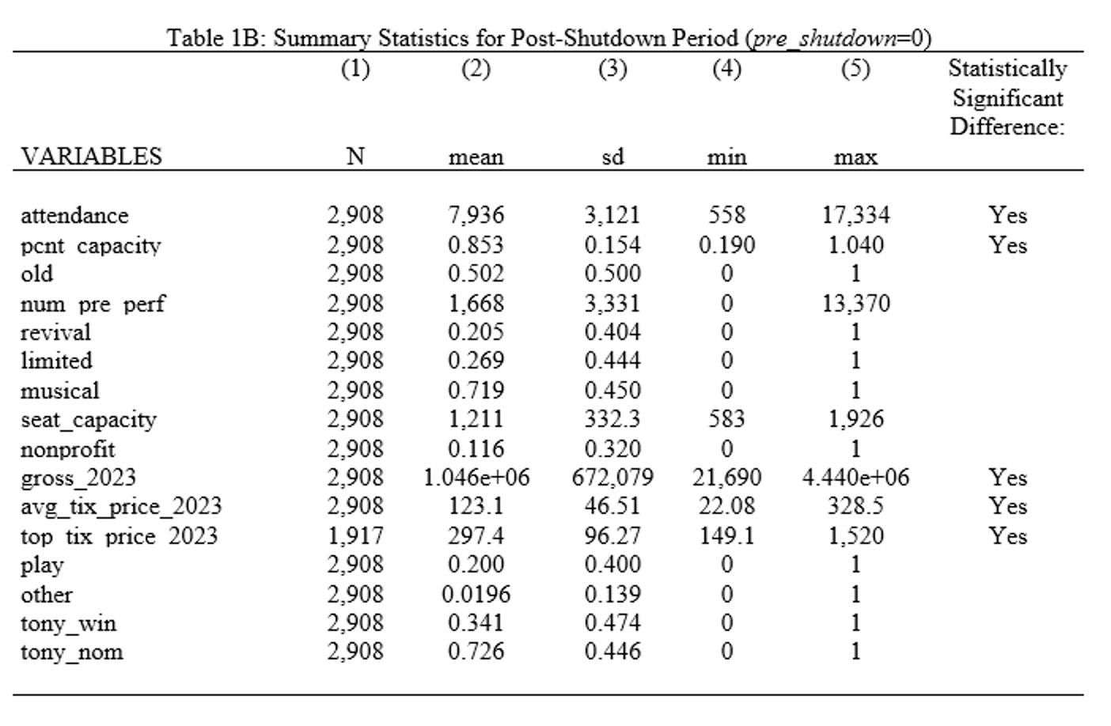

Note: Table 1A and 1B presents summary statistics for the periods before (*pre_shutdown*=1) and after (*pre_shutdown*=0) the shutdown caused by the COVID-19 pandemic. Data on gross, attendance, and percent capacity were collected from IBDB. Data on average ticket prices and top ticket prices were collected from Playbill. Data on *limited* were collected from Broadway World; *limited* is a binary variable for whether the production was a limited run. Data on *tony_win* and *tony_nom* were collected from TonyAwards.com. The variables *gross_2023*, *avg_tix_price_2023*, and *top_tix_price_2023* are inflation adjusted variables using September 2023 USD. These three variables, in addition to *attendance* and *pcnt_capcity* are weekly measures. *Pcnt_capacity* indicates what percent of the total weekly theater capacity was filled that week. This differs from *seat_capcity* which is the physical number of seats in the theaters. *Seat_capacity* is different between the pre- and post-shutdown periods because of the removal of seats from the Broadway Theater for the 2023 production of *Here Lies Love.* T-tests confirm that the differences between the pre- and post-shutdown periods are statistically significant for all five measures of success.

4. Methods and Results

## Effect of pre_shutdown on Measures of Production Success

The first set of regressions measures how production characteristics impact production success. The main variable of interest is *pre_shutdown*, which is an indicator of whether the week of an observation occurred before or after the shutdown (1). This would enable me to see if there are differences in production success between the pre-shutdown and post-shutdown periods, while controlling for other production characteristics. This regression was run with and without fixed effects for theaters. The variable *Yit* represents each of the five measures of production success: *gross_2023*, *attendance*, *pcnt_capcity*, *avg_tix_price_2023*, and *top_tix_price_2023*. Equation (1) was estimated with and without theater fixed effects.

(1) *Yit* = β0+β1*pre_shutdownit*+β2*musicalit*+β3*otherit*+β4*revivalit*+

β5*limitedit*+β6*nonprofitit*+β7*tony_winit*+β8*tony_nomit*+u

The results from estimating equation (1) are presented in Table 2A and Table 2B. All coefficients of *pre_shutdown* were statistically significant at the 1% level of significance. This means that, when controlling for additional characteristics, productions are predicted to be more successful before the COVID-19 shutdown. This was true with and without the inclusion of theater fixed effects.

Before the shutdown, productions saw $191,193 more in weekly gross, $17.22 more in weekly average ticket prices, and $63.14 more in weekly top ticket prices, on average. Compared to the means presented in Table 1B, before the pandemic, weekly grosses were 13.6% higher, weekly average ticket prices were 14.0% higher, and weekly top ticket prices were 21.2% higher. When including theater fixed effects, the surplus in gross and average ticket prices is even higher; before the pandemic, productions are expected to see $249,874 in weekly average gross and $23.41 more in weekly average ticket prices. This means that, when controlling for theater fixed effects, weekly grosses were 23.9% higher and average ticket prices were 19.0% higher before the pandemic. I would argue that all these figures, both with and without the inclusion of fixed effects are large enough to be economically significant.

According to this model, attendance and percent capacity were also higher before the shutdown. Productions were expected to see 513.8 more weekly attendees before the shutdown, which means that weekly attendance was 6.5% higher before the shutdown. When controlling for theater fixed effects, which would presumably control for the seating capacity of theaters, this figure rises to 621.1 more weekly attendees, which means that weekly attendance was 7.8% higher before the shutdown. The economic significance of attendance can also be determined by comparing attendance to seat capacity. As reported in Table 1B, the mean seat capacity in the post-shutdown period was 1,211 seats.[5] Because the typical Broadway production holds eight performances each week, one could consider the average weekly capacity to be 9,688 seats. If the post-shutdown period had 513.8 fewer weekly attendees compared to before the shutdown, this was equivalent to 5.3% of the average total available seats per week. When controlling for theater fixed effects, 621.1 attendees comprises 6.4% of the average total available seats per week.

When looking at the percent capacity of theaters, before the shutdown, theaters were more full by 3.07 percentage points, or by 4.45 percentage points when controlling for theater fixed effects. This means that the capacity of theaters was 3.6% higher before the shutdown, or 5.2% higher when controlling for theater fixed effects. Though the impact on attendance and percent capacity might seem smaller compared to the impact on gross and ticket prices, I would argue that these figures still hold economic significance. Broadway theaters run on tight margins, so even seemingly small dips in attendance can greatly impact profits and whether a production remains open.

In general, the coefficients of the remaining regressors have the expected sign. In several of the regressions, however, *tony_win* is expected to decrease the success of a production. This result is even more surprising when in the same model *tony_nom* is expected to increase production success. For example, this unusual pairing can be seen in Column 2 and Table 2A. It is possible that this effect is due to an omitted variable that I have not considered and would need to research further.

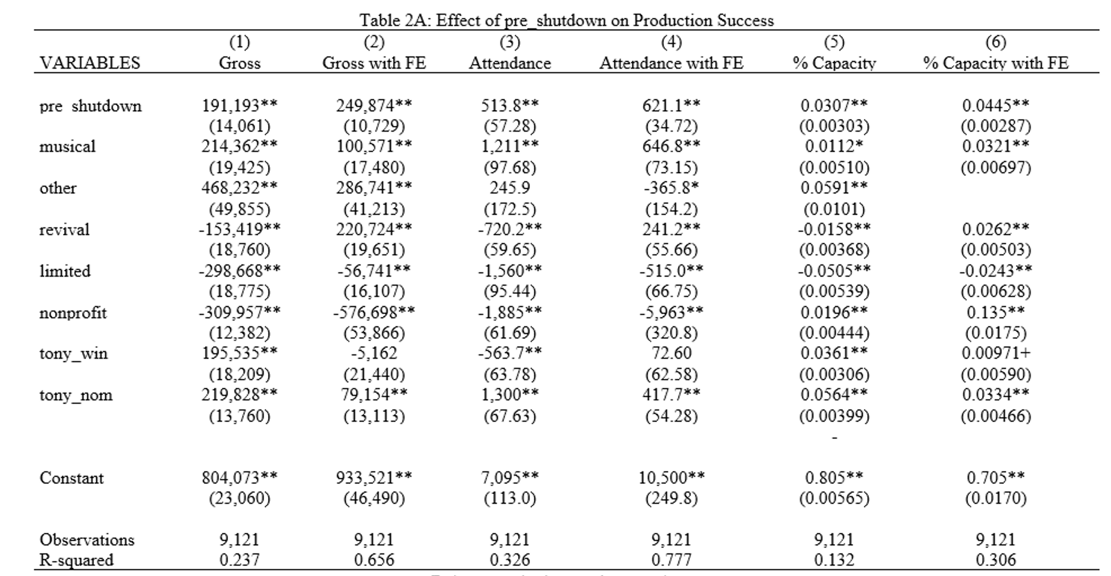

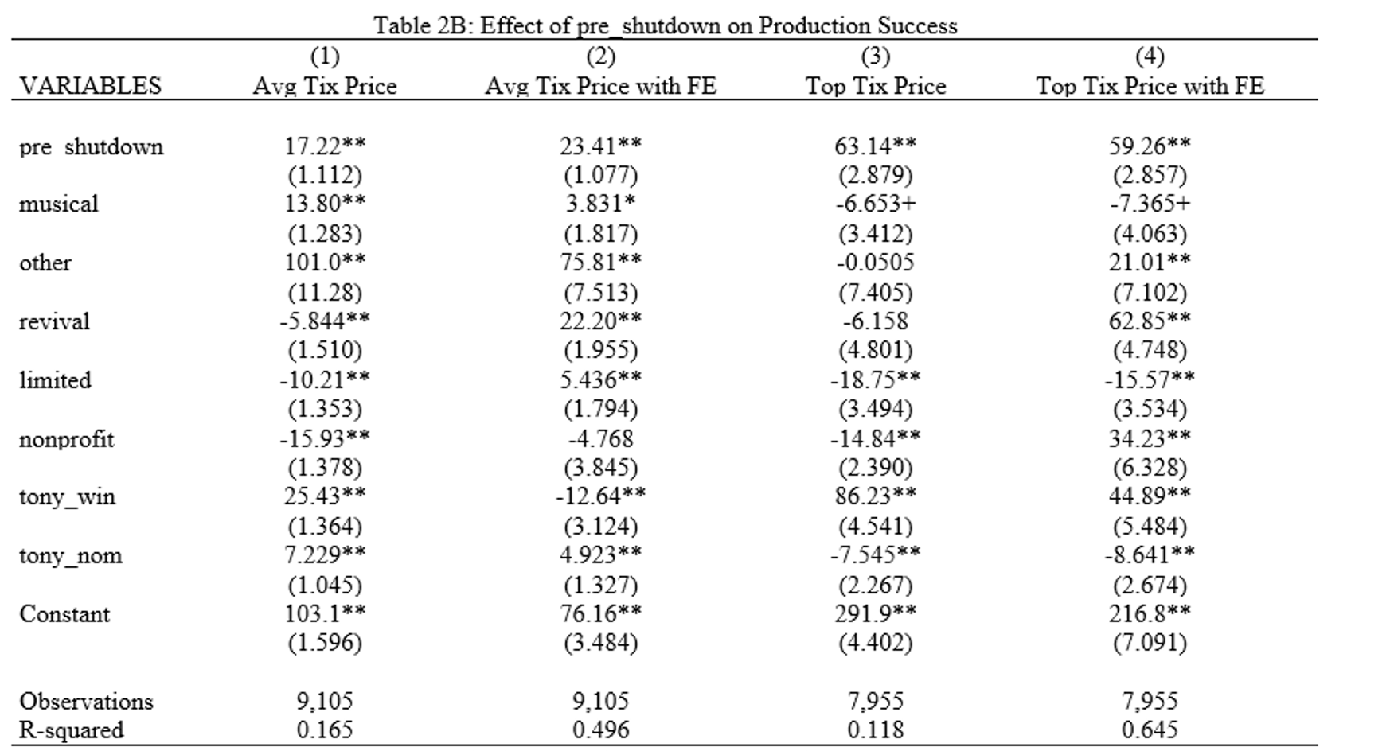

Note: Robust standard errors are reported in parentheses. **p<0.01, *p<0.5, +p<0.1 The results in Table 2A Columns 1, 3, and 5, and Table 2B Columns 1 and 3 are from estimating (1) by OLS. The results in Table 2A Columns 2, 4, and 6, and Table 2B Columns 2 and 4 are from estimating (1) by OLS with fixed effects for theaters.

## Effect of Pre-shutdown Longevity on Measures of Production Success

I next turn to measuring the effects of pre-shutdown longevity on the five measures of productions’ success. The two measures of pre-shutdown longevity are the binary variable *old* and the continuous variable *num_pre_perf*. Both of these variables are the same for all weeks that a production was open. For these regressions, I limit the sample to the post-shutdown (pre_shutdown=0) period. This allows me to see how pre-shutdown longevity impacted productions’ success specifically after Broadway reopened.

### “Old” as a Measure of Pre-shutdown Longevity

The following set of regressions estimate how production characteristics impact production success. The main variable of interest is *old*, which is an indicator of whether a production existed before the shutdown.[6] This would enable me to see whether there are differences in production success based on whether a production existed before the shutdown, while controlling for other production characteristics. Equation (2) is estimated by OLS, and this regression was estimated with and without theater fixed effects. The variable *Yit* represents each of the five measures of production success: *gross_2023, attendance, pcnt_capacity, avg_tix_price_2023,* and *top_tix_price_2023*. Further, this model only looks at weeks where *pre_shutdown*=0, which restricts the model to the post-shutdown period.

(2) *Yit* = β0+β1*oldit*+β2*musicalit*+β3*otherit*+β4*revivalit*+β5*limitedit*+β6*nonprofitit*+

β7*tony_winit*+β8*tony_nomit*+u*it*

The results from estimating equation (2) are presented in Tables 3A and 3B. If a production existed before the shutdown (*old*=1), it is expected to have higher grosses, attendance, and average ticket prices in the post-shutdown period, however, it is also expected to have lower top ticket prices. These results are statistically significant at the 1% level of significance. Without the inclusion of theater fixed effects, being an old production in the post-shutdown period did not have any significant impact on the percent capacity of theaters.

Being an old production during the post-shutdown period is predicted to increase weekly gross by $191,409 and to increase weekly attendance by 1,363 people. Compared to the means reported in Table 1B, being an old production in the post-shutdown period is expected to increase weekly gross by 18.3% and weekly attendance by 17.2%. If one compares the impact of attendance to the mean number of seats available each week, then being an old production in the post-shutdown period is predicted to increase weekly attendance by 14.1% of the average total weekly capacity.

Being an old production in the post-shutdown period is predicted to decrease top ticket prices by $31.16. This means that being an old production in the post-shutdown period is expected to decrease top ticket prices by 10.5% This result is also economically significant, though not necessarily surprising. Older productions have already established themselves in the market and may choose to lower their ticket prices to compete with newer productions. The higher average ticket prices for old productions compared to new productions, however, could indicate that there is less variation in ticket prices for old productions. Again, this could be because old productions have already established themselves in the market and know what prices to charge so that their tickets sell.

When controlling for theater fixed effects, the impact on weekly average ticket prices and weekly top ticket prices are more prominent. Being an old production in the post-shutdown is expected to increase weekly average ticket prices by 17.5% and to decrease weekly top ticket prices by 10.5% when controlling for theater fixed effects. Thus, these two figures hold even greater economic significance than those in the model without theater fixed effects.

With the inclusion of theater fixed effects, being an old production now has a negative effect on attendance and percent capacity in the post-shutdown period. Old productions are expected to see 799.7 fewer weekly attendees, which is a 10.1% decrease in weekly attendance or 8.3% of average total weekly capacity. In addition, old productions are expected to see a decrease in percent capacity of theaters by 5.15 percentage points (a 6.0% decrease in percent capacity). For reasons discussed in the previous section, I would argue that these results are economically significant, despite being lower than the figures for gross and ticket prices.

The coefficients on the remaining regressors are mostly of the expected sign. As was seen in the previous section, the coefficient of *tony_win* is sometimes negative, such as in Column 1 in Table 3A. This would indicate that winning a Tony Award is expected to have a negative effect on success. This is especially surprising when a negative coefficient of *tony_win* is in the same model as a positive coefficient for *tony_nom* (for example, in Table 3A, Column 1). It is possible that there is an omitted variable influencing these results that I have not considered to include in my models.

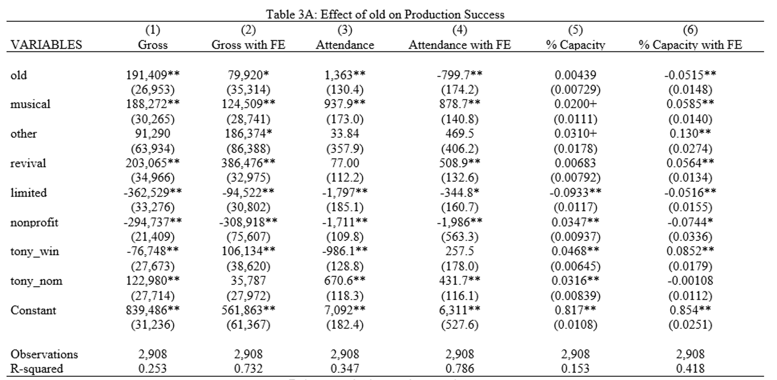

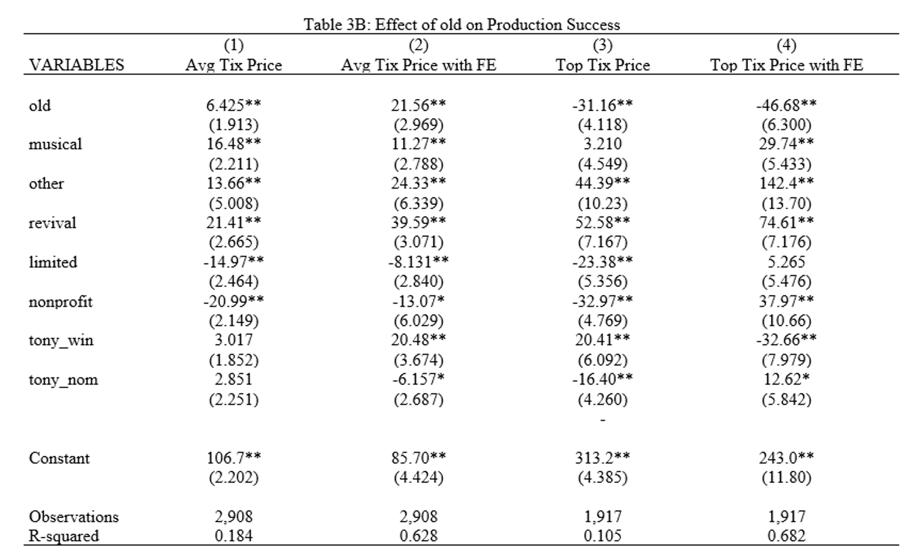

Note: Robust standard errors are reported in parentheses. **p<0.01, *p<0.5, +p<0.1 The results in Table 3A Columns 1, 3, and 5, and Table 3B Columns 1 and 3 are from estimating (2) by OLS. The results in Table 3A Columns 2, 4, and 6, and Table 3B Columns 2 and 4 are from estimating (2) by OLS with fixed effects for theaters.

### 

### Number of Pre-shutdown Performances as a Measure of Pre-shutdown Longevity

The following set of regressions estimate how production characteristics impact production success. The main variable of interest is *num_pre_perf*, which indicates how many performances a production had before the shutdown (3). This allows me to see if there were differences in production success based on how many pre-shutdown performances a production had, while controlling for other production characteristics. Equation (3) was run with and without theater fixed effects. The variable *Yit* represents each of the five measures of production success: *gross_2023*, *attendance*, *pcnt_capcity*, *avg_tix_price_2023*, and *top_tix_price_2023*. Further, this model only looks at weeks where *pre_shutdown*=0, which restricts the model to the post-shutdown period.

(3) *Yit* = β0+β1*num_pre_perfit*+β2*musicalit*+β3*otherit*+β4*revivalit*+β5*limitedit*+

β6nonprofit*it*+β7tony_win*it*+β8tony_nom*it*+u*it*

The results from estimating equation (3) are presented in Tables 4A and 4B. An increase in the number of pre-shutdown performances was predicted to increase gross and attendance, however, it was also predicted to decrease percent capacity, average ticket prices, and top ticket prices. Because, however, these regressions predict the change in success from one additional pre-shutdown performance, most results are too minute to hold economic significance. Therefore, it may be more insightful to think of how an additional week of pre-shutdown performances impacts production success. Since Broadway productions typically hold eight performances each week, the effect of an additional week of pre-shutdown performances can be found by multiplying the results by eight. Still, with this adjustment, the impact of *num_pre_perf* on percent capacity, average ticket price, and top ticket price remains below 1, and the impact of *num_pre_perf* on gross and attendance remains negligible to overall totals at $256.88 and 2.544 people respectively.

When including fixed effects, the number of pre-shutdown performances retains its positive impact on gross and attendance. In fact, it now has positive impacts on all five measures of production success. In addition, the magnitude of *num_pre_perf*’s coefficient has increased in all five regressions. This increased impact of the number of pre-shutdown performances on success would also suggest that these results are more economically significant than the results without theater fixed effects. However, even when looking at the impact of one week of pre-shutdown performances, these results are still quite negligible compared to overall weekly figures. For example, the impact of eight pre-shutdown performances on weekly percent capacity, average ticket prices, and top ticket prices is still less than 1. The impact on weekly gross and attendance is $2,459.20 and 4.752 people, respectively. These results could suggest that the number of pre-shutdown performances is not a reliable indicator of post-shutdown success.

Alternatively, the results of these regressions can be scaled using the standard deviation of *num_pre_perf* for all productions in the *old*=1 category.[7] This can be done by multiplying the results by 3,448 performances, which is the standard deviation for *num_pre_perf* for all old productions. Thus, with the inclusion of theater fixed effects, a one standard deviation increase in the number of pre-shutdown performances is expected to increase gross by 101.3% and attendance by 25.8%.[8] In addition, this increase is expected to increase percent capacity by 11.7%, average ticket prices by 90.5% and top ticket prices by 19.1%, with the inclusion of theater fixed effects.

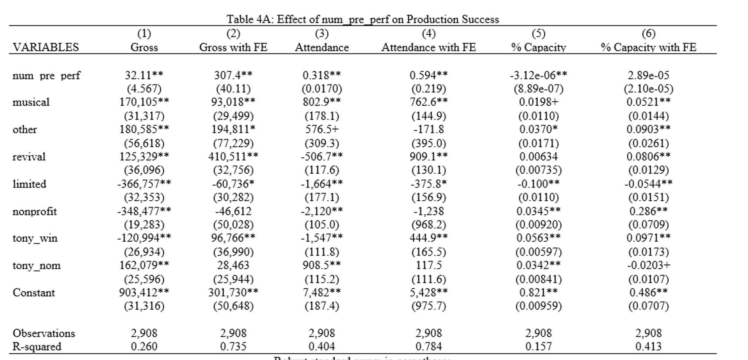

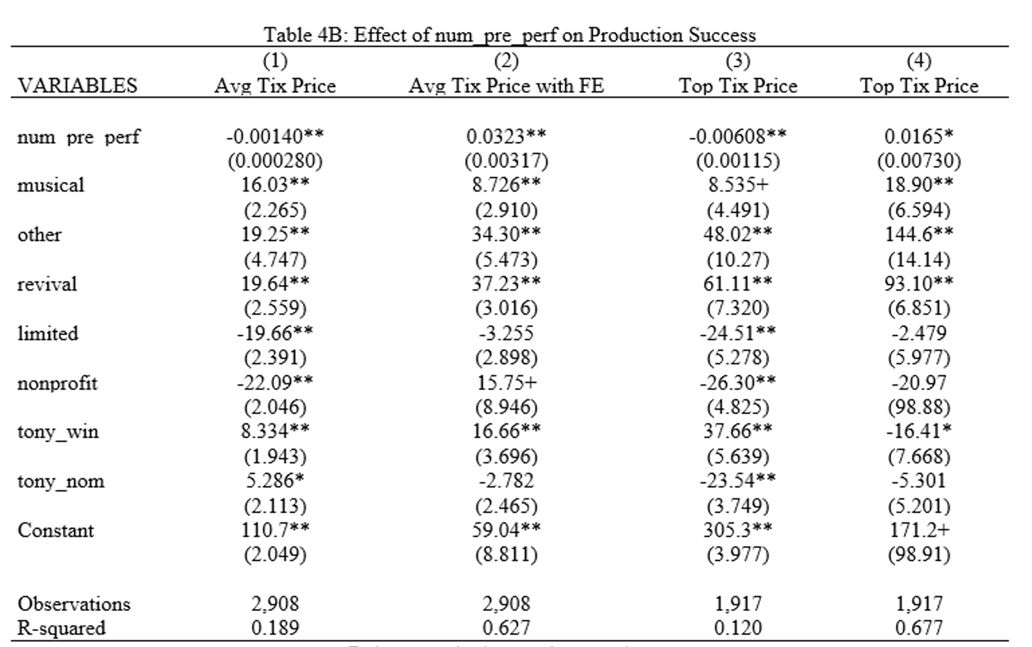

Note: Robust standard errors are reported in parentheses. **p<0.01, *p<0.5, +p<0.1 The results in Table 4A Columns 1, 3, and 5, and Table 4B Columns 1 and 3 are from estimating (3) by OLS. The results from Table 4A Columns 2, 4, and 6, and Table 4B Columns 2 and 4 are from estimating (3) by OLS with fixed effects for theaters.

## 

## Effect of Pre-shutdown Performances on Survival

For the final set of regressions, a new dependent variable *survived* was created. *Survived*=1 if a production was open during the last week before the shutdown *and* reopened at any date after the shutdown. Data was limited to observations that were *old*=1. This was because new productions (*old*=0) did not exist before the shutdown, and thus, did not have a chance at surviving the shutdown. *Survived* was regressed on *pre_num_perf* using the same controls as the previous sets of regressions (4). This regression was estimated with and without theater fixed effects.

(4) *survivedit* = β0+β1*num_pre_peritf*+β2*musicalit*+β3*otherit*+β4*revivalit*+β5*limitedit*+

β6*nonprofitit*+β7*tony_winit*+β8*tony_nomit*+u*it*

The equation in (4) was estimated using both OLS and probit models. The results are presented in Table 5. Column 3 and 4 report probit marginal effects.

In all four models, *num_pre_perf* has a statistically significant impact on productions’ chance of survival. In the models without fixed effects (Column 1 and 3), an increase in the number of pre-shutdown performances is predicted to increase the probability of survival. In the fixed effects models (Column 2 and 4), however, an increase in the number of pre-shutdown performances is predicted to decrease the probability of survival. Despite this statistical significance, these results hold very little economic significance. In none of the four models is *num_pre_perf* predicted to increase or decrease the probability of survival by more than 1%. Thus, in these models, the impact of *num_pre_perf* on survival is minute and practically negligible.

Other characteristics, however, are more telling. In particular, being a revival is expected to decrease a production’s chance of survival by 27.7% in the OLS model and by 54.4% in the probit model. If a production takes place in a theater that is run by a non-profit organization, this is expected to decrease the chance of survival by 30.8% in the OLS model and 51.9% in the probit model. Winning a Tony Award is expected to increase the probability of survival by as much as 38.2% (Column 4), while being nominated for a Tony Award is expected to increase the probability of survival by as much as 51.7% (Column 3).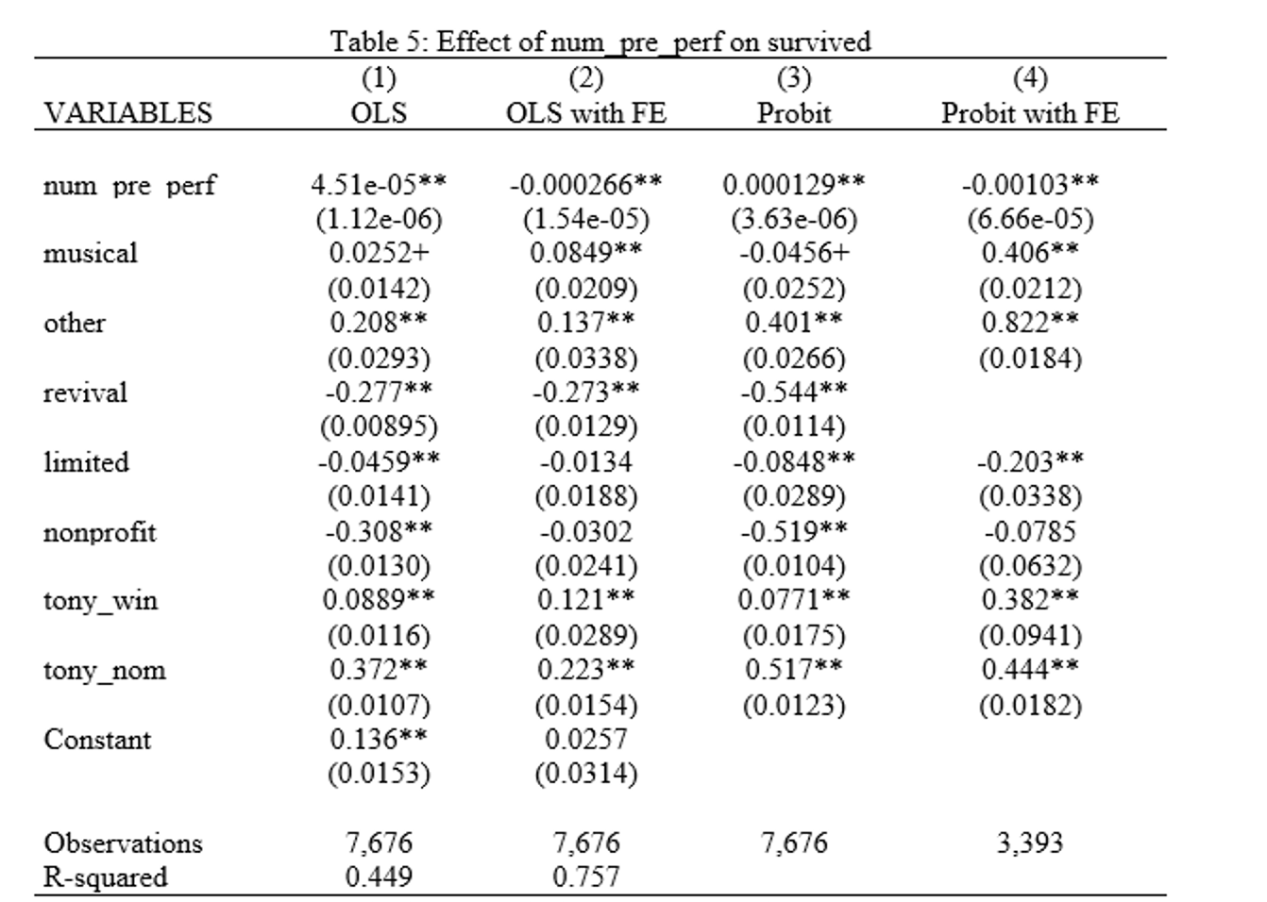

Note: Robust standard errors are reported in parentheses. **p<0.01, *p<0.5, +p<0.1 Columns 1 and 2 report the results of estimating (4) by OLS. Columns 3 and 4 report the probit marginal effects. Columns 2 and 4 include fixed effects for theaters. Data is limited to productions in the *old*=1 group.

## 

## Survival Analysis

Finally, as an alternative to the regression models, a Cox proportional hazards model was used to predict the likelihood that a production survived. Because of its functionality, this model only looks at observations for the last week that a production was open. This way, there is only one observation per production, rather than weekly observations for each week that a production was open. Additionally, this model drops all *old*=1 productions that did not have any performances after the shutdown. It only looked at new productions that opened after the shutdown and old productions that reopened after the shutdown. This reduced the total number of observations to n=104. The hazard model uses similar controls to the previous regression models. Instead of theater fixed effects, however, the variable *seat_capacity* was added to control for the number of seats in theaters. Pre-shutdown longevity is measured using the variable *old*. The results of these models are presented in Table 6.

In this model, failure is represented by the closure of a production. Although somewhat counterintuitive, variables with positive coefficients are associated with a higher likelihood of failure, while variables with negative coefficients are associated with a lower likelihood of failure. The hazard models produced very few statistically significant results, however, the main regressor *old* is statistically significant at the 5% level. This would suggest that if a production was open before the shutdown, it would be less likely to survive compared to new productions that did not exist until after the shutdown. In other words, in the period after the shutdown, new productions were more likely to survive.

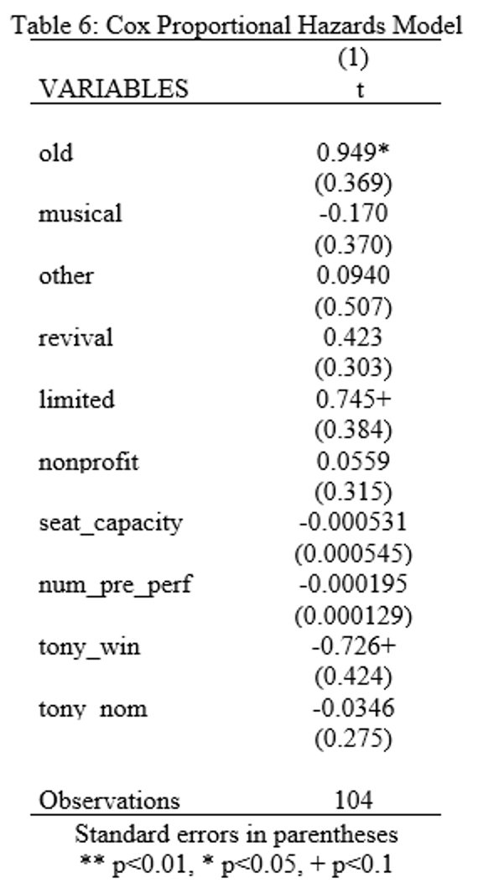

Note: Table 6 presents the coefficients of a Cox proportional hazards model that predicts productions’ survival of the COVID-19 shutdown. This model only includes new productions (*old*=0) and old productions (*old*=1) that occurred in both the pre-shutdown and post-shutdown periods. Of this group, the model only uses observations for the final week a production was open, or 1 observation per production. The total sample size is n=104.

5. Conclusion

This study sought to answer the question: *how does the longevity of Broadway productions impact their ability to overcome economic shocks, in this case a devastating recession caused by a global pandemic?* In order to answer this question, I examined how pre-shutdown longevity impacted post-shutdown success as measured in weekly gross, attendance, percent capacity of theaters, average ticket prices, and top ticket prices.

The first section of this study established that there were statistically and economically significant differences between the overall success of Broadway productions in the pre-shutdown period and the overall success of Broadway productions in the post-shutdown period. It was found that productions were expected to be more successful before the pandemic as measured by all five measures of weekly success.

Of the two measures of pre-shutdown longevity, *old* was found to be a more meaningful predictor compared to *num_pre_perf*. There was found to be greater differences in success between old and new productions than between old productions of differing pre-shutdown longevity. It is possible that a different measure of pre-shutdown longevity, such as weeks instead of performances, might yield more meaningful results to differentiate between old productions.

It was found that being an old production in the post-shutdown period did have a statistically and economically significant impact on the success of Broadway productions. Being an old production in the post-shutdown period was expected to increase weekly gross, attendance, average ticket prices, and percent capacity of theaters, however, being an old production in the post-shutdown period was expected to decrease weekly top ticket prices. When controlling for theater fixed effects, most of these effects remain, except that being an old production in the post-shutdown period is expected to decrease weekly attendance.

Most of the additional regressors had the expected sign and magnitude in their effects on production success. One notable exception was the instances when winning a Tony Award was expected to decrease production success, especially when being nominated for a Tony Award was simultaneously expected to increase production success. It is possible that this is the result of omitted variable bias, so an improvement for this study might be to research further variables to include in the regression models.

Because the COVID-19 pandemic was a global event, it is possible that this study might have external validity when wanting to learn how the pandemic affected other theater districts, such as those in London, Toronto, and Melbourne. London’s West End is especially comparable to Broadway because of the similar lineup of productions and their reputations as being international tourist destinations. Potential threats to the external validity of this study might include differences in COVID-19 restrictions that were implemented in New York and those that were implemented in London or other theater districts.

The economics literature on Broadway theater is limited, and the literature analyzing the COVID-19 pandemic’s impact on Broadway is practically nonexistent because of the recency of the event. This study provides a small glimpse into how the shutdown caused by the pandemic impacted Broadway productions based on whether or not they existed before the pandemic. Hopefully, more research will be devoted to this and similar topics in the future.

6. Appendix

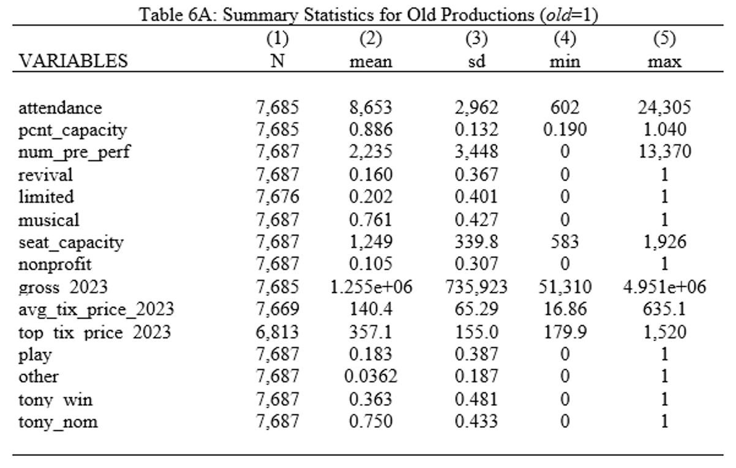

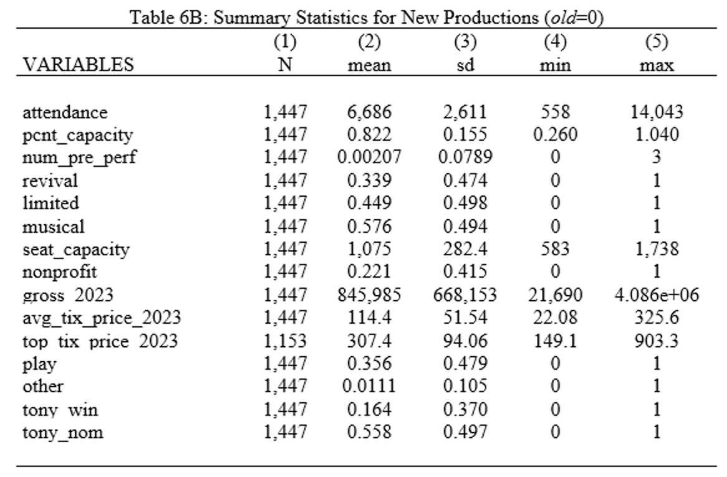

Note: Tables 6A and 6B present summary statistics for productions that existed before the shutdown caused by the COVID-19 pandemic (*old*=1) and productions that were new after the shutdown (*old*=0). Data on gross, attendance, and percent capacity were collected from IBDB. Data on average ticket prices and top ticket prices were collected from Playbill. Data on *limited* were collected from Broadway World; *limited* is a binary variable for whether a production was a limited run. Data on *tony_win* and *tony_nom* were collected from TonyAwards.com. The variables *gross_2023*, *avg_tix_price_2023*, and *top_tix_price_2023* are inflation adjusted variables using September 2023 USD. These three variables, in addition to *attendance* and *pcnt_capcity* are weekly measures. *Pcnt_capacity* indicates what percent of the total weekly theater capacity was filled that week. This differs from *seat_capcity* which is the physical number of seats in the theaters. *Seat_capacity* is different between the pre- and post-shutdown periods because of the removal of seats from the Broadway Theater for the 2023 production of *Here Lies Love.*

Works Referenced:

Boyle, M., & Chinou, L. (2009). Broadway productions and the value of a Tony Award. *Journal*

*of Cultural Economics*, *33*, 49–68.

Coase, R. H. (1972). Durability and monopoly. *The Journal of Law and Economics*, *15*(1),

143–149. https://doi.org/10.1086/466731

Courty, Pascal. “An Economic Guide to Ticket Pricing in the Entertainment Industry.”

Recherches Économiques de Louvain / Louvain Economic Review 66, no. 2 (20n.d.): 167–92.

Goldstein, M. (2022, October 4). Why Are So Many Broadway Shows Closing? *Forbes*.

Hauser, K. (November 2019). The Demographics of the Broadway Audience. *Broadway League*.

Retrieved May 5, 2023.

Jaworski, Taylor, Maggie E.C. Jones, and Mario Samino. “Entry Pricing and Broadway.”

Applied Economics Letters 25, no. 10 (2018): 653–58.

Leslie, Phillip. “Price Discrimination in Broadway Theater.” The RAND Journal of Economics

35, no. 3 (2004): 520–41.

Maclean, K. D. (2021). Value of stars on Broadway: A case study. *Service Science*, *13*(2), 77–87.

https://doi.org/10.1287/serv.2021.0273

Maclean, K. D., & Ødegaard, F. (2022). Revenue implications of celebrities on Broadway

Theatre. *Journal of Revenue and Pricing Management*. https://doi.org/10.1057/s41272-022-00392-9

Maddison, D. (2005). Are there too many revivals on Broadway? A stochastic dominance

approach. *Journal of Cultural Economics*, *29*(4), 325–334. https://doi.org/10.1007/s10824-005-0867-y

Nygren, L. M., &amp; Simonoff, J. S. (2007). Bright Lights, Big Dreams - A Case Study of

Factors Relating to the Success of Broadway Shows.

Pisani, J. (2022, June 21). Broadway to end mask mandate in july. Wall Street Journal. Retrieved

December 12, 2023, from https://www.wsj.com/articles/broadway-to-end-mask-mandate-in-july-11655833917.

Reddy, S. K., Swaminathan, V., &amp; Motley, C. M. (1998). Exploring the determinants of

Broadway show success. Journal of Marketing Research, 35(3), 370. https://doi.org/10.2307/3152034

Stock, J. H., & Watson, M. W. (2019). *Introduction to econometrics* (4th ed.). Pearson.

The Broadway League. (n.d.). *The Phantom of the Opera*. Internet Broadway Database (IBDB).

https://www.ibdb.com/broadway-production/the-phantom-of-the-opera-4491#Statistics[9]

The Broadway League. (2023). The Tony Award Nominations. The Tony Award Nominations |

The American Theatre Wing’s Tony Awards®.[10]

https://www.tonyawards.com/nominees/year/2023/category/any/show/any/

The Broadway League. (2023, September 17). *Grosses list | playbill*. Playbill.

https://playbill.com/Grosses/[11]

Wisdom Digital Media. (n.d.). *The Phantom of the Opera*. BroadwayWorld.

https://www.broadwayworld.com/shows/The-Phantom-of-the-Opera-6624.html[12]

Zieba, M. (2015). Tourism flows and the demand for regional and city theatres in Austria.

*Journal of Cultural Economics*, *40*(2), 191–221. https://doi.org/10.1007/s10824-015-9250-9

1. Not all productions in the *old*=1 group reopened after the shutdown.
2. Of the 41 Broadway theaters, 6 are run by non-profit organizations: American Airlines Theatre, Stephen Sondheim Theatre, and Studio 54, which are run by Roundabout Theatre Company; Hayes Theatre, which is run by Second Stage; Samuel J. Friedman Theatre, which is run by Manhattan Theatre Club; and Vivian Beaumont Theatre, which is run by Lincoln Center Theater.
3. *Tony_win* and *tony_nom* only apply to the specific productions within the dataset; if a production is a revival of a previous production that won or was nominated for a Tony Award, the applicable variable(s) would still equal 0, unless the specific production within the dataset also won or was nominated. Additionally, neither of these variables control for additional categories of the Tony Awards, such as those for Best Actors Actresses or those for Best Scenic Design.
4. When observations for *limited*, *attendance, pcnt_capacity, gross_2023, avg_tix_price_2023,* and *top_tix_price* are missing, that data were unreported for a particular production and/or week.
5. The difference in seating capacity between the pre-shutdown and post-shutdown period was due to the removal of 900 seats from the Broadway Theatre for the 2023 production of *Here Lies Love.* To account for this change in seating capacity, previous productions that took place in the Broadway Theatre were coded as theater=“Broadway Theatre” while *Here Lies Love* was coded as theater= “Broadway Theatre 2023”.
6. Summary statistics for *old*=1 and *old*=0 can be found in the Appendix (Table 6A and 6B)
7. Summary statistics for *old*=1 and *old*=0 productions are reported in Table 6A and 6B in the Appendix.
8. As in previous sections, percent increases are calculated using the means in Table 1A.
9. IBDB profile for *The Phantom of the Opera.* Other productions’ IBDB profiles are in a similar format.
10. Tony Award nominations and winners for 2023. Lists for other years are in a similar format
11. Playbill weekly data for the week ending in September 17, 2023. Data for other weeks are in a similar format.
12. Broadway World profile for *The Phantom of the Opera.* Other productions’ Broadway World profiles are in a similar format.