From Relocation to Higher Education: An Empirical Analysis of Japanese American College Attainment Post-Internment

Caitlin Kawamura

Advisor: Professor Svec

Readers: Professor Congdon-Hohman & Professor Rodrigues

Department of Economics and Accounting

April 2, 2024

**Abstract:**

In 1942, the United States government removed over 120,000 people of Japanese ancestry from the West Coast and incarcerated them in internment camps. I investigate one potential lasting legacy of internment by empirically examining its effect on different age cohorts’ decisions to attend and complete college. Results indicate that college attainment rates decreased for internees 15 years after internment ended before increasing 25 years afterward relative to my West Coast non-Japanese Asian American control group. Additionally, I find that internment more greatly impacted those interned as older children and teenagers than those interned as younger children, and the effect’s magnitude was greater for males than females. To understand why college attainment changed in the decades following internment, I empirically explore internees’ loss of wealth. I also consider other alternatives including shifts in discrimination levels and family emphasis on education using accounts from former internees, including an interview I conducted. These findings provide broader insight into trauma’s various impacts on children and young adults.

**Introduction:**

In times of war, leaders sometimes disregard ethics and the constitutional rights of a country’s citizens in the name of national security. Japanese internment during World War II represents how “racial prejudice, wartime hysteria, and a failure of political leadership” can result in systemic failures by the government to uphold all Americans’ civil rights (USC 50 Ch. 52 § 4202(a)). While internment lasted for an average of three years (beginning in 1942) with camps closing at the end of 1945 (WRA 1946, 17),[1] the effects on the over 120,000 Japanese interned lasted much longer. Internees suffered almost total losses of wealth and experienced psychological trauma. Thus, as the United States began to build economic stability and wealth through increases in education, movement into white-collar jobs, and investment in physical capital in the post-war period, Japanese Americans emerged from the war stripped of their homes, jobs, and opportunities for higher education.

This paper explores one potential lasting legacy of internment by examining its effect on different age cohorts’ decisions to attend and complete college. Using a difference-in-differences model, this paper empirically analyzes college attainment rates for internees 15 (1960) and 25 years after internment (1970) holding age cohorts constant across time. I find that internee college attainment decreased in 1960 before increasing in 1970 relative to the control group, suggesting that internment negatively impacted college attainment for those interned as older children and teenagers and positively impacted it for those interned as younger children. The effect’s magnitude was also greater for males than females. To strengthen and thoroughly evaluate these empirical results, I interviewed a former internee whose lived experiences I incorporate throughout the discussion section. The historical background section and literature review provide further context about internment and present previous analyses of internment’s various long-term impacts. This paper concludes by considering several factors for why college attainment increased for internees between 1960 and 1970. These findings provide broader insight into trauma’s various impacts on children and young adults.

**Historical Background:**

On February 19, 1942, President Franklin Delano Roosevelt issued Executive Order 9066 giving Secretary of War Henry Stimson and military commanders the power to “prescribe military areas…from which any or all persons may be excluded” in response to the attack on Pearl Harbor. Officials, including then California state Attorney General Earl Warren,[2] pushed unfounded fears of the Japanese acting as “potential fifth columnist[s]” intent on sabotaging the West Coast (Katcher 1967, 145).[3] This led Western Defense Commander General John DeWitt to designate much of Arizona, California, Oregon, and Washington (collectively referred to as the West Coast) as a military zone (Reeves 2015, 54). He then quickly ordered the removal of all people of Japanese ancestry from the West Coast (Reeves 2015, 54). Carried out under the guise of national unity and justified as the wartime sacrifice West Coast Japanese “should be glad to make” (Reeves 2015, 65), Japanese internment represented the culmination of anti-Asian and anti-Japanese sentiment rather than an isolated event.

The Japanese first immigrated to the continental United States through Hawaii in the early 1900s (Nagata 1998, 126). American businesses had previously recruited Chinese immigrants to work as cheap labor between 1840 and 1880 so that by 1870 Chinese immigrants constituted 25 percent of California’s workforce (Chan 2019, 207). Following the passage of a series of anti-Chinese laws, including the Chinese Exclusion Act of 1882 which banned immigration from China for 10 years, these businesses began recruiting Japanese immigrants not excluded by the Act (Chan 2019, 208). As the Japanese started to experience economic success, particularly in agriculture, the federal and state governments passed anti-Japanese laws (Chan 2019, 210). Like the anti-Chinese laws before them, the legislation attempted to curb Japanese immigrants’ economic mobility by barring them from owning land in many western states (1914 Alien Land Law) and from becoming naturalized citizens (1924 Johnson-Reed Act). This culminated in the Johnson-Reed Act’s passage in 1924 (otherwise known as the Oriental Exclusion Act) which prohibited all immigration from Asia to the United States.

By the time Japan bombed Pearl Harbor on December 7, 1941, society viewed Japanese and Chinese immigrants as a “yellow peril” that would corrupt the country (Nagata 1998, 127). Consequently, General DeWitt’s order giving over 120,000 West Coast Japanese, ⅔ of whom were American-born citizens (WRA 1946, 67), just one week to put their affairs in order and prepare for internment sparked little public outcry (Nagata 1998, 127). Forced to sell their businesses and belongings to speculators for pennies on the dollar since they could only bring what they could carry, the Japanese saw their homes and land foreclosed on because the government froze their bank accounts (Reeves 2015, 75). The Federal Reserve Bank in San Francisco conservatively estimated that Japanese property losses stood at $400 million (equivalent to $7.55 billion today) (Caudill and Mixon 2012, 5-6). One managing secretary from the Grower-Shipper Vegetable Association admitted that economic opportunism rather than security concerns motivated civilian support for internment saying, “If all the Japs were removed tomorrow, we’d never miss them…because the white farmers can take over and produce everything the Jap grows” (Grodzins 1949, 27-28). Exclusion and internment also meant the disruption of Japanese American college students’ studies, some of whom would never finish (Nakadate 2013, 85). Importantly, internment only applied to Japanese living on the West Coast and not to those in Hawaii (where the Japanese composed 37 percent of the island’s population) nor to the rest of the continental United States (Chin 2005, 496).[4] Large-scale internment of people of German or Italian ancestry also never occurred (Chin 2005, 496-497).

Despite the injustice of internment, the Japanese resisted little due to a combination of factors including financial ruin, a lack of political voice (the average age among Japanese Americans was just 19 (Reeves 2015, 75)), the government’s removal of community leaders following Pearl Harbor,[5] cultural values emphasizing respect for authority, complicated cultural identity conflicts between America and Japan, and the presence of armed guards when registering for evacuation (Nakadate 2013, 120). The government first placed the majority of Japanese in assembly centers throughout the West Coast for about three months before sending them to one of 10 permanent internment camps in remote locations throughout the United States (Nagata 1998, 128).[6] Behind the camps’ barbed wire and surrounded by armed guards, the War Relocation Authority (WRA), the agency in charge of overseeing internment, assigned each family a single room ranging in size from 20 by eight feet to 20 by 24 feet in a military-style barrack housing multiple other families (Nagata 1998, 128). The WRA also fed, educated, and encouraged internees to work (although the jobs were menial and paid just $12 to $19 per month–approximately $215 to $330 today)[7] (Chin 2005, 493-494). They also formed community organizations in an effort to live as normally as possible (Reeves 2015, xviii). Internees stayed in the camps for a mean of three years and a median of 3.5 years although the WRA did allow some earlier releases (Chin 2005, 494).

Upon release from the camps in 1945, the WRA gave internees just $25 to cover a train ticket to their next destination and meals (Reeves 2015, 259). On July 2, 1948, the government passed the Evacuation Claims Act to partially compensate internees for relocation and resulting financial losses they incurred; only about 10 percent of former internees, however, possessed the proper documents to file a claim leaving the vast majority to rebuild their lives from scratch (Nakadate 2013, 192). The Act gave them just 18 months to file for compensation with former internees eventually filing 23,689 claims totaling $148 million (roughly $1.89 billion today) (US CWRIC1983, 118). The government ultimately distributed only $37 million to claimants (about $470 million today) compensating them just 25 cents on the dollar for losses (US CWRIC1983, 118). Only after the passage of the Civil Liberties Act of 1988 did the government acknowledge that internment was not a military necessity but an injustice. It also paid reparations of $20,000 to each surviving internee and issued a letter of apology (Caudill and Mixon 2012, 6). The families of deceased internees received nothing.

**Literature Review:**

Much of the research on internment comes from sociological, historical, and legal fields, as well as personal accounts written by internees. Until relatively recently, however, little economics research had appeared on this topic. Since Aimee Chin published her seminal 2005 piece on the long-run effects of labor market withdrawal caused by internment, economics research on internment has expanded to cover additional labor outcomes (Arellano-Bover 2022), the effects of camp placement (Saavedra 2013; Shoag and Corrollo 2016), and social and educational outcomes (Caudill and Mixon 2012; Saavedra 2021; Saavedra 2015). Most of the literature focuses on internment’s long-term impacts, particularly on male internees.

Both Aimee Chin and Jaime Arellano-Bover examine the long-run effects of internment on labor outcomes. Using individual-level data from the 1970 Census, Chin finds that internment-induced labor market withdrawal decreased the annual earnings of formerly interned working-age males by nine to 13 percent 25 years later (Chin 2005, 505) and reduced their chances of holding white-collar occupations (Chin 2005, 493). She hypothesizes that internment caused a loss of labor market experience and led former internees to take less suitable jobs (Chin 2005, 516). Building on Chin’s research, Arellano-Bover argues that financial losses and geographical displacement stemming from internment (including subsequent migration to non-West Coast states), prompted internees to change occupations at higher rates after the war (Arellano-Bover 2022, 130). This, somewhat surprisingly, resulted in annual income increases of nine to 22 percent five to 15 years after internment as younger internees moved from farming jobs into professional and technical ones (Arellano-Bover 2022, 129-130). Differences in methodologies could explain these varying results. Chin’s (2005) research compares younger internees against older internees, while Arellano-Bover (2022) examines internment’s overall impacts by comparing internees to a control group of West Coast Chinese Americans.

Other authors examine the impact of internment camp location on long-term outcomes. Daniel Shoag and Nicholas Carollo (2016) find that internees placed in camps in richer areas (such as Gila River in Arizona) experienced better economic outcomes including higher socioeconomic status, income, housing price and quality, and education than those placed in camps in poorer areas (such as Jermone in Arkansas) provided they remained in the same state post-internment. Additionally, internees assigned to more socially mobile areas saw less correlation between their children’s economic outcomes and their own (Shoag and Carollo 2016, 28). Martin Saavedra’s research on internment’s long-term effects on lifespans finds that males interned during their first four years of life died 1.63 years earlier compared to non-interned Japanese Hawaiians (Saavedra 2013, 3). Using a difference-in-differences methodology that links WRA records to the Social Security Death Index, he determines that internees from low socioeconomic status families mostly drive this effect, and those interned in cold climates experienced a more negative average treatment effect (such as Wyoming) than warm ones (such as California) (Saavedra 2013, 19).

As Saavedra and Steven B. Caudill and Franklin G. Mixon Jr. study, anti-Japanese sentiment and internment also changed how the Japanese saw their place in American society. Saavedra argues that the combined effects of the 1941 Pearl Harbor bombings and the subsequent increase in anti-Japanese sentiment (acted on through internment) (Saavedra 2021, 603), led to a seven percentage point increase in Americanized names given to Japanese American children born between 1941 and 1942 as they attempted to assimilate (Saavedra 2021, 615). Caudill and Mixon examine how internment changed investment decisions among former internees. They find that internment-induced property losses led internees to invest more in formal education while substituting away from more riskily perceived physical capital investments (Caudill and Mixon 2012, 9). Their paper, however, uses a dataset for its Japanese observations taken from the 1966 Japanese American Research Project survey and compares it to 1960 Census data for white and African American outcomes (Caudill and Mixon 2012, 8). Nevertheless, the authors note their findings’ consistency with economic theory and other studies on public choice and human capital investment (Caudill and Mixon 2012, 8).

Saavedra’s research on long-run educational outcomes for child internees who attended WRA-run schools most relates to this paper. Using data pooled from the 1980, 1990, and 2000 Censuses (Saavedra 2015, 63), he divides internees into an older, school-aged cohort born between 1930 and 1936 and a younger, non-school-aged cohort born between 1937 and 1941 (Saavedra 2015, 67). His results suggest that the older, school-aged internees who attended WRA schools were between 4.2 and 5.4 percentage points less likely to obtain any graduate education and between 1.9 and seven percentage points less likely to earn a bachelor’s degree than the younger, non-school-aged cohort. Overall, this decreased years of schooling by between 0.14 and 0.46 years for the school-aged cohort (Saavedra 2015, 68). He argues that in internment’s absence, West Coast Japanese would have become more educated than non-West Coast Japanese Americans (Saavedra 2015, 68).

Additionally, anthropological and psychological research has studied the long-term impacts of internment-induced trauma. Gwendolyn M. Jensen finds age at internment correlated with increased cardiovascular disease and mortality risk compared to non-interned Japanese Americans (22 to 26 year-olds were most vulnerable and seven to 11 year-olds were least vulnerable) (Jensen 1997). Several authors contend that disruptions caused by internment to education and career plans made college-aged internees more likely to report feelings of stress and injustice than younger ones (Fugita and Fernandez 2004; Nagata and Takeshita 1998, 594). Contrastingly, limited awareness about internment’s significance led those interned as young children to be more likely to recall feelings of adventure and positive experiences in the camps, including forming friendships (Fugita and Fernandez 2004; Nagata and Takeshita 1998, 594). These trends match broader findings that people exposed to trauma at older ages experience larger negative physical and mental health effects than those exposed during childhood (Lynch and Lachman 2020).

This paper adds to the literature in three ways. First, I build on Saavedra’s research on school quality and educational attainment by analyzing bachelor’s attainment and completion of some college in 1960 (15 years after internment) and 1970 (25 years after internment) using Census data. I examine how internment impacts these metrics separately across these two time periods rather than aggregating data from the 1980, 1990, and 2000 Censuses. Second, I use a methodology that analyzes internment’s impact by creating constant age cohorts rather than birth cohorts. This allows me to study changes in college attainment rates of people interned as babies to teenagers but measured at the same age in my 1960 and 1970 analyses. It also expands on how childhood trauma affects long-term outcomes among different age cohorts. Lastly, I provide novel results that capture internment’s effect on females in addition to males.

**Data:**

This paper uses microdata from the 1940, 1960, and 1970 US Census and American Community Survey taken from IPUMS. Individual-level data for 1940 employs the full-count Census, while data for 1960 and 1970 pools observations from five percent and four percent of the population, respectively (Ruggles et al. 2024). (After 1950, the full-count Census was unavailable.)

Importantly, the Census does not ask about internment status which makes studying internment’s impact challenging. Therefore, I proxy internment status with three restrictions. First, following Chin, I only define Census respondents as internees if they recorded “Japanese” as their race in each Census year (Chin 2005, 500). Second, respondents must be American citizens (as measured by the respondent’s birthplace) due to an inability to differentiate between Japanese immigrants who entered the country after 1945 and noncitizen internees. Third, like Saavedra, I leverage the fact that the government interned 97 percent of West Coast Japanese (Saavedra 2015, 63). Therefore, I assume that the respondents I designate as internees lived on the West Coast prior to internment. Given that I analyze college educational attainment across three separate time periods (1940, 1960, and 1970), I define West Coast residency differently depending on the year, as discussed below.

Specifically, I designate my 1940 pre-internment group of Japanese Americans as West Coast residents if they lived in either Arizona, California, Oregon, or Washington that year. It is highly likely that the vast majority of this group still lived in one of these states in 1942 and was thus interned. In my 1960 and 1970 analyses, I restrict my internee sample to those born in Arizona, California, Oregon, or Washington before 1942. I rely on the fact that 80 percent of people live within 100 miles of where they grew up (Hendron, Porter, and Sprung-Keyser 2022). For internees included in my 1970 analysis born between 1942 and 1945, and therefore after the removal to the internment camps, I adjust the West Coast restriction to only contain Japanese born in one of the seven states housing the 10 internment camps (Arizona, Arkansas, California, Colorado, Idaho, Utah, or Wyoming). While no direct way exists to distinguish between a Japanese person born into a non-West Coast internment camp and one born into a non-interned family living in a state with an internment camp, 87 percent of the continental United States’ Japanese population was interned (Chin 2005, 492). Thus, counting these observations as internees is reasonable. Taken together, I identify Census respondents as internees if they selected their race as Japanese, are American citizens by birth, and were living or born on the West Coast before 1942 and born in one of the states with an internment camp after 1942.

Next, I specifically estimate the impact of internment on college educational attainment. I compare the college attainment of 25-36 year-old Japanese Americans in 1960 and 1970 with the college attainment of 25-36 year-old Japanese Americans in 1940.[8] Hence, this enables me to exclude all of the Census respondents’ unobservable characteristics that remain culturally stable across time. I then make the same comparison by subdividing the 25-36 year-olds into a younger, middle, and older age group: 25-30 year-olds, 27-32 year-olds, and 31-36 year-olds. Notably, average college attainment in the United States has likely changed between 1940 and 1970 which could distort my estimate of internment’s impact. To remove this concern, I compare the change in Japanese Americans of different age cohorts' educational outcomes with the change in a control group’s educational outcomes.

Table 1: Age Cohorts by Birth Years

|  |  |  |  |
| --- | --- | --- | --- |
| Age Cohort | Birth Year of 1940 Census Respondent | Birth Year of 1960 Census Respondent | Birth Year of 1970 Census Respondent |
| 25-36 | 1904-1915 | 1924-1935 (10-21 in 1945) | 1934-1945 (0-11 in 1945) |
| 25-30 | 1910-1915 | 1930-1935 (10-15 in 1945) | 1940-1945 (0-5 in 1945) |
| 27-32 | 1908-1913 | 1928-1933 (12-17 in 1945) | 1938-1943 (2-7 in 1945) |
| 31-36 | 1904-1909 | 1924-1929 (16-21 in 1945) | 1934-1939 (6-11 in 1945) |

Thus, I compare the treated Japanese American internees against a non-Japanese Asian American control group composed of people who marked “Chinese” or “Other Asian or Pacific Islander” for the Census’s race question. Like those interned, they must also be American citizens living on the West Coast in 1940 or born there for the 1960 and 1970 samples. (Because this group was not interned, their birthplace did not change to reflect states with internment camps during the war years.) Following Arellano-Bover, non-Japanese Asian Americans serve as a comparable control group because they were not interned during the war but faced similar levels of anti-Asian discrimination on the West Coast to Japanese Americans (Arellano-Bover 2022, 128). In the next section, I test this group’s validity as a control group for those interned.

Table 2 presents summary statistics by year. Internees compose a majority of the total sample (between 61 and 72 percent), while West Coast non-Japanese Asian Americans (labeled “Control”) make up the other 28 to 39 percent. This paper measures two different types of college educational attainment: completion of a bachelor’s degree and completion of at least one year of college (labeled “Some College”). The sample’s education level increases between 1940 and 1970 with 7.2 percent of Census respondents across both groups holding a bachelor’s degree and 15.82 percent completing at least one year of college in 1940. By 1970, this rises to 35.81 percent of both groups holding a bachelor’s degree and 65.42 percent completing some college. For reference, just 11 percent of all Americans over 25 held a bachelor’s degree and only 21.2 percent had attained some college in 1970 (US Bureau of the Census 1970, 1). In 1940, males outnumbered females, comprising 56.52 percent of the sample. The gender balance equalizes in 1960 and 1970, however, with males making up 49.7 percent and 49 percent of the sample, respectively. On average, internees and West Coast non-Japanese Asian Americans were 28.8 years old in 1940, 30.6 years old in 1960, and 29.4 years old in 1970. Notably, 1940 contains significantly more observations than 1960 and 1970, because I drew the 1940 data from the full 1940 Census compared to just a sample of the 1960 and 1970 Censuses.

Before turning to the regression design, I first graph the two groups’ college attainment paths over time. Graphs 1-4 show mean college attainment rates for 25-36 year-olds and the three subdivided age cohorts. I omit attainment rates for 1950 since I focus on internment’s effects in 1960 and 1970; however, I include graphs with the 1950 rates in the appendix. As measured by both bachelor’s degrees and some college attainment, internees completed more college than the control group in 1940 and 1970. Following their release from the camps, though, former internees’ mean college attainment significantly dropped in 1960 so that they attended less college than the control group for a period of time. While all the graphs show the same trends in 1960 and 1970 for college attainment, the degree to which internment appears to have affected each age cohort varies.

Table 2: Summary Statistics by Year

|  |  |  |  |  |  |
| --- | --- | --- | --- | --- | --- |
|  | (1) | (2) | (3) | (4) | (5) |
| VARIABLES | N | Mean | SD | Min | Max |
| 1940 |  |  |  |  |  |
| Bachelor’s  Some College | 14,078  14,078 | 0.072  0.158 | 0.259  0.365 | 0  0 | 1  1 |
| Internee | 14,078 | 0.716 | 0.451 | 0 | 1 |
| Control | 14,078 | 0.284 | 0.451 | 0 | 1 |
| Male | 14,078 | 0.576 | 0.494 | 0 | 1 |
| Age    1960 | 14,078 | 28.84 | 3.275 | 25 | 36 |
| Bachelor’s  Some College  Internee  Control  Male  Age    1970  Bachelor’s  Some College  Internee  Control  Male  Age | 1,954  1,954  1,954  1,954  1,954  1,954      1,307  1,307  1,307  1,307  1,307  1,307 | 0.191  0.431  0.721  0.279  0.497  30.56      0.358  0.654  0.605  0.395  0.490  29.44 | 0.393  0.495  0.449  0.449  0.500  3.398      0.480  0.476  0.489  0.489  0.500  3.619 | 0  0  0  0  0  24      0  0  0  0  0  24 | 1  1  1  1  1  36      1  1  1  1  1  36 |
|  |  |  |  |  |  |

Overall, internees and West Coast non-Japanese Asian Americans started with almost identical levels of college education in 1940 as Graph 1 shows. By 1960, though, non-Japanese Asian American college attainment outstripped internees’ bachelor’s attainment by roughly four percentage points and some college attainment by nine percentage points. 25-30 year-old internees were 2.3 percentage points less likely to attend at least a year of college and approximately 6.4 percentage points less likely to earn a bachelor’s degree than non-Japanese Asian Americans of the same age. The 27-32 year-old cohort displays a similar but more extreme pattern, as nearly 53 percent of the control group had completed some college compared to 43.7 percent of internees in 1960 (a 9.3 percentage point gap). 27-32 year-old internees also were approximately 7.1 percentage points less likely to earn a bachelor’s degree than the control group. Interestingly, the oldest age group (the 31-36 year-olds) experienced a significantly larger gap in some college completion than in bachelor’s degree attainment in 1960. This cohort was just 1.1 percentage points less likely to earn a bachelor’s degree but almost 12 percentage points less likely to complete some college compared to the control group’s 31-36 year-olds. This is suggestive evidence that internment harmed both the middle cohort’s bachelor’s and some college attainment, while also more negatively impacting the older cohort’s ability to start college and the younger cohort’s ability to complete college.

Graph 1: College Attainment Rates for 25-36 Year-Olds

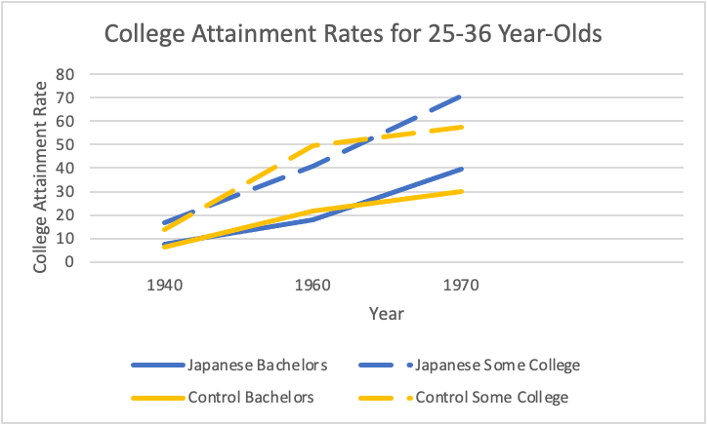

Graph 2: College Attainment Rates for 25-30 Year-Olds

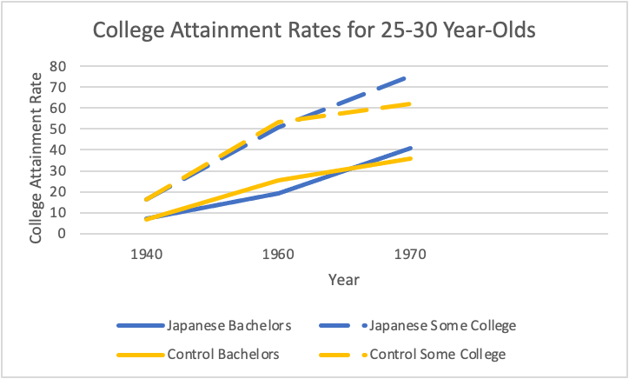

Graph 3: College Attainment Rates for 27-32 Year-Olds

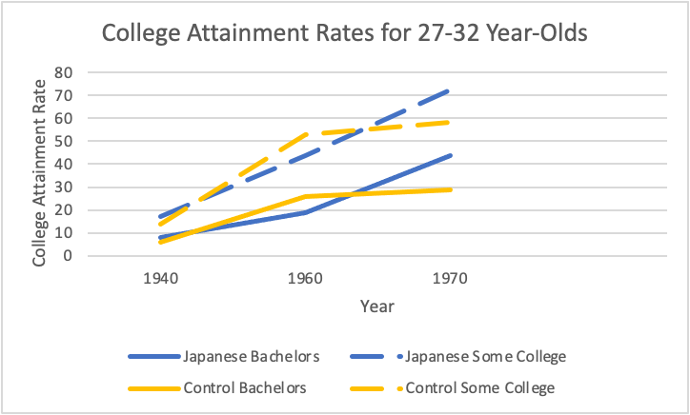

Graph 4: College Attainment Rates for 31-36 Year-Olds

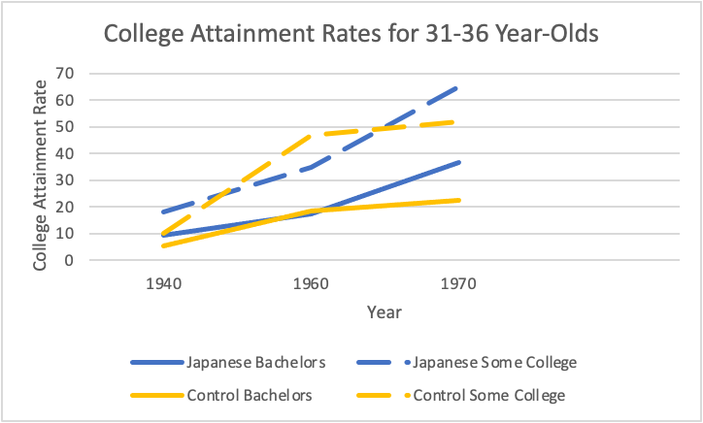

Between 1960 and 1970, former internees’ mean college attainment surpassed non-Japanese Asian Americans’ attainment. Overall, internees became 9.9 percentage points more likely to earn a bachelor’s degree and 13.3 percentage points more likely to attend some college compared to the control. By 1970, 25-30 year-old former internees became approximately five percentage points more likely to earn a bachelor’s degree and 13.4 percentage points more likely to complete some college compared to the control group. Most dramatically, 27-32 year-old former internees became roughly 15 and 14.3 percentage points more likely to earn a bachelor’s degree and complete some college than the control group, respectively. 31-36 year-old internees experienced similar changes in college attainment. Compared to the control, they became roughly 14.3 and 13.25 percentage points more likely to earn bachelor’s degrees and attend some college. This is suggestive evidence that those interned at slightly older ages completed college at higher rates relative to the control.

Importantly, these raw percentages do not represent internment’s causal impact on college attainment. I have not controlled for any related factors such as gender or age, nor have I shown that internment’s impact on college attainment rates is significantly different statistically from zero. In the next section, I introduce the empirical methodology I use to test for internment’s causal impact on internees’ educational outcomes.

**Empirical Model:**

To analyze the effect of internment on college attainment, I employ a difference-in-differences model using Census cross-sectional data for each age cohort. Put simply, I test for whether college attainment rates of a particular age cohort (such as 25-30 year-olds) change in response to internment relative to the non-Japanese Asian American control group, controlling for Census respondents’ age and gender. I use the following model:

*College Attainmenti,t= β0+β1Interneei+β2Postt+β3(Interneei*Postt)+β4Malei+β5Agei+β6Age2i+β7Yeart+ui,t*

where the dependent variable, College Attainmenti,t, measures the educational outcome of individual *i* responding to the Census in year *t.* I measure college attainment in two ways: whether the individual completed a bachelor’s degree (four or more years of college) and whether the individual completed at least one year of college by Census year *t.* Interneei is a binary variable equal to one if an individual is designated as an internee (Japanese American and from the West Coast), and equal to zero if an individual is part of the control group. Postt is also a binary variable that equals one if the Census year is later than 1945. β3 represents the average effect of internment on internees’ college attainment rates. I include Malei, Agei,Age2i,andYeart as additional explanatory variables as gender and age are likely related to educational outcomes and American college attainment has increased over time.

Critically, this model assumes parallel trends between internees and the non-Japanese Asian American control group, implying that in the absence of internment, internees’ educational attainment would have grown at the same rate as the control group’s across time. In selecting West Coast non-Japanese Asian Americans as my control group, I rely on Arellano-Bover’s use of a West Coast Chinese American control group and Saavedra’s use of a West Coast non-Japanese Asian American control group (Arellano-Bover 2022, 128; Saavedra 2015, 60). I also consider how both groups historically experienced similar levels of anti-Asian discrimination on the West Coast to justify my use.

To directly test for parallel trends, I would need to compare the college attainment path of 25-36 year-old Japanese Americans with that of the 25-36 year-old non-Japanese Asian American control group before internment. If the paths were similar (or only separated by a constant), then I could be relatively confident that my regression results captured internment’s impact on internees’ college attainment. Unfortunately, I cannot directly run this test. While I have the 1940 Census data, the 1930 Census does not ask about educational attainment or related variables such as income. Hence, I attempt an alternative method of testing for parallel trends to determine 25-36 year-old non-Japanese Asian Americans’ suitability as a control group for those interned. Rather than comparing trends within an age cohort over time, I examine the two groups’ college attainment in 1940 *across age cohorts.* I make this choice because college attainment among individuals aged 35-46 in 1940 should be almost identical to the college attainment of 25-36 year-olds in 1930. (Consistent with how the Census reports educational data, I assume that college attainment largely plateaus at age 25.)

I can thus test for parallel trends by measuring the change in college attainment between 25-36 year-old Japanese Americans and 35-46 year-old Japanese Americans against the control group in 1940. With an appropriately designed post variable (based on an individual’s age cohort in 1940 rather than time), a statistically insignificant interaction term would suggest parallel trends were present before internment because West Coast Japanese Americans’ and the control group’s college attainment was growing at the same rate. I use the following model based on difference-in-differences:

*College Attainmenti= β0+β1Japanesei+β2Youngi+β3(Japanesei*Youngi)+β4Malei+β5Agei+β6Age2i+ui*

where the dependent variable, College Attainmenti, measures the educational outcome of individual *i* responding to the Census in 1940. Japanesei is a binary variable with the same 1940 restrictions as the previous Interneei variable. Most importantly, this model makes one key adjustment. Instead ofPostt denoting time, Youngi now represents whether an individual is part of the older 35-46 year-old cohort (equal to zero) or the younger 25-36 year-old cohort (equal to one). Youngi, therefore, captures the change in college attainment over time that Postt would capture with the 1930 data. I include Malei, Agei,and Age2i as additional controls.

Using this model, I empirically check for pre-internment parallel trends between Japanese Americans and the control group for both bachelor’s degree attainment and some college completion as Table 3 shows. I find that the parallel trends assumption holds for bachelor’s degree attainment as the interaction term is statistically insignificant. This suggests that 25-36 year-old Japanese Americans’ college attainment path from 1930 to 1940 was similar to that of non-Japanese Asian Americans. As a result, my control group reliably approximates Japanese Americans’ bachelor’s degree attainment had they not been interned during World War II. The assumption fails, however, for some college attainment as it is statistically significant. This suggests that one should have less confidence in non-Japanese Asian Americans acting as a comparable control group when considering internment’s impact on whether internees obtained some college education.

Table 3: 1930-1940 Pre-Internment College Attainment Parallel Trends Results

|  |  |  |
| --- | --- | --- |
|  | (1) | (2) |
| VARIABLES | Bachelor’s | Some College |
|  |  |  |
| Japanese | 0.0234*** | 0.0575*** |
|  | (0.00746) | (0.00972) |
| Young (Ages 25-36) | 0.0129 | 0.0536*** |
|  | (0.00934) | (0.0125) |
| Japanese*Young | -0.00879 | -0.0400*** |
|  | (0.00903) | (0.0122) |
| Male | 0.0388*** | 0.0726*** |
|  | (0.00375) | (0.00529) |
| Age | 0.0149*** | 0.00567 |
|  | (0.00378) | (0.00530) |
| Age2 | -0.000229*** | -0.000123 |
|  | (5.44e-05) | (7.61e-05) |
| Constant | -0.209*** | -0.00729 |
|  | (0.0664) | (0.0931) |
|  |  |  |
| Observations | 17,375 | 17,375 |
| R-squared | 0.008 | 0.019 |

Robust standard errors in parentheses

*** p<0.01, ** p<0.05, * p<0.1

Importantly, ordinary least squares best measures continuous dependent variables. Both bachelor’s degree attainment and completion of at least one year of college are defined as binary variables equal to one if the individual has obtained the necessary education. Hence, a nonlinear probit model more accurately measures these variables and allows me to interpret the marginal effects of internment. Following Saavedra (Saavedra 2015, 65-66), I, therefore, use the following probit model to strengthen my results from the linear difference-in-differences model:

*P(Y=1|X1, X2,...,X7) = Φ[β0+β1Interneei+β2Postt+β3(Interneei*Postt)+β4Malei+β5Agei+β6Age2i+β7Yeart+ui,t]*

where Y=1 is the binary outcome that an individual attained either a bachelor’s degree or completed at least one year of college education, and Y=0 if otherwise. β3 represents the change in the underlying probability density function which I then convert to internment’s marginal effect at the mean using the cumulative distribution values. This captures the change in the probability that Y=1.

**Results:**

I now evaluate my empirical results regarding internment’s impact on college attainment judged as the completion of a bachelor’s degree and at least one year of college. To summarize, I find that internment negatively impacted college attainment compared to the non-Japanese Asian American control group in 1960. By 1970, however, I find the opposite: relative to the control group, internment led to an increase in college attainment. These results are consistent using both the linear difference-in-differences model with robust standard errors and the nonlinear probit model. The probit model also indicates that internment more greatly impacted males than females, likely reflecting how more males attended college during this time than females (NCES 2015). Consistent with the findings on age and internment-induced trauma discussed in the literature, internment more negatively affected those interned as older children and teenagers than younger children in 1960. In 1970, however, internment increased the 27-32 year-old cohort’s (released from the camps as two to seven year-olds) overall college attainment more than the other cohorts.

Table 4 reports the difference-in-differences results for the four age cohorts, including both definitions of college attainment using the 1960 data. Table 5 reports the same results using the 1970 data. I run the same specifications for Tables 6 and 7 but use the probit model rather than ordinary least squares. For those tables, I show internment’s marginal impact on males (first line) and females (second line).

Examining the tables’ results, internment’s overall impact on 25-36 year-old internees’ (released from the camps between ages 10 and 21) bachelor’s degree and some college attainment was large and statistically significant in 1960 and 1970. While college attainment grew between 1940 and 1960, internment caused a 5.37 percentage point smaller increase in bachelor’s degree attainment compared to the non-Japanese Asian American control group. Male internees experienced a 4.88 percentage point smaller increase in bachelor’s attainment, while female internees experienced a 2.95 percentage point smaller increase relative to the control as shown by the probit model’s marginal effects. Internment also led to a 10.7 percentage point smaller increase in some college attainment compared to the control. Males were 9.48 percentage points less likely, and females were 6.88 percentage points less likely to start college relative to the control. These findings all hold at the one percent significance level.

By 1970, interment increased college attainment compared to the control. 25-36 year-old internees (released from the camps as zero to 11 year-olds) became 8.35 percentage points more likely to earn a bachelor’s degree relative to the control (significant at the one percent level). Male internees experienced a 2.93 percentage point larger increase, and female internees experienced a 1.95 percentage point larger in bachelor’s attainment relative to the control (significant at the 10 percent level). More dramatically, internment caused an 11.1 percentage point larger increase in some college attainment compared to the control. Males became 8.16 percentage points, and females became 6.12 percentage points more likely to begin college compared to the control. The some college results are all significant at the one percent level.

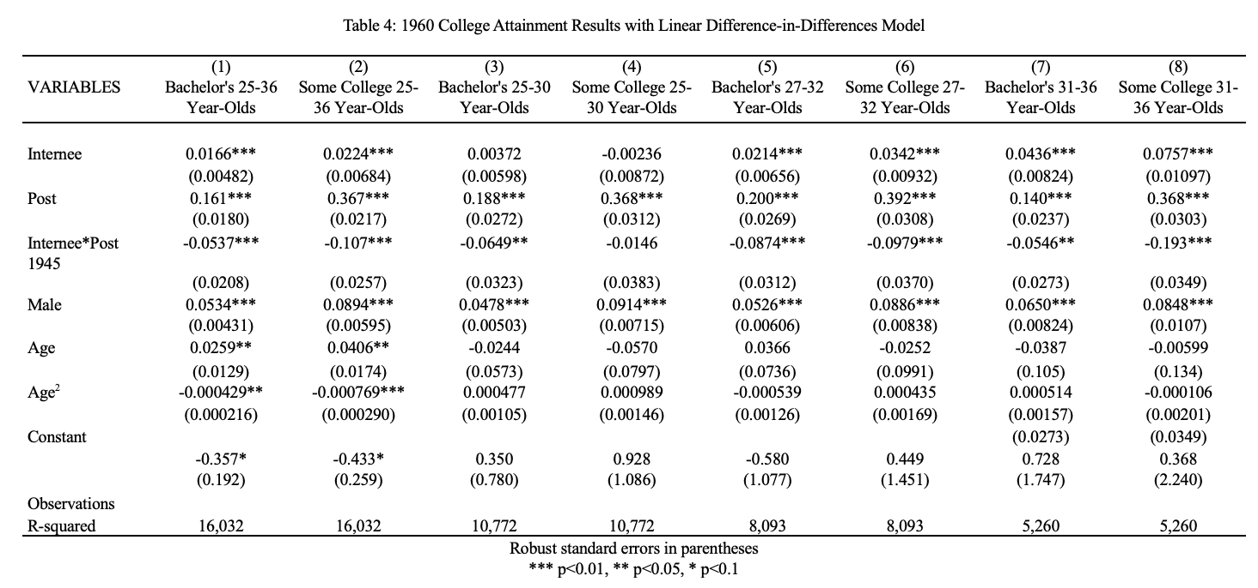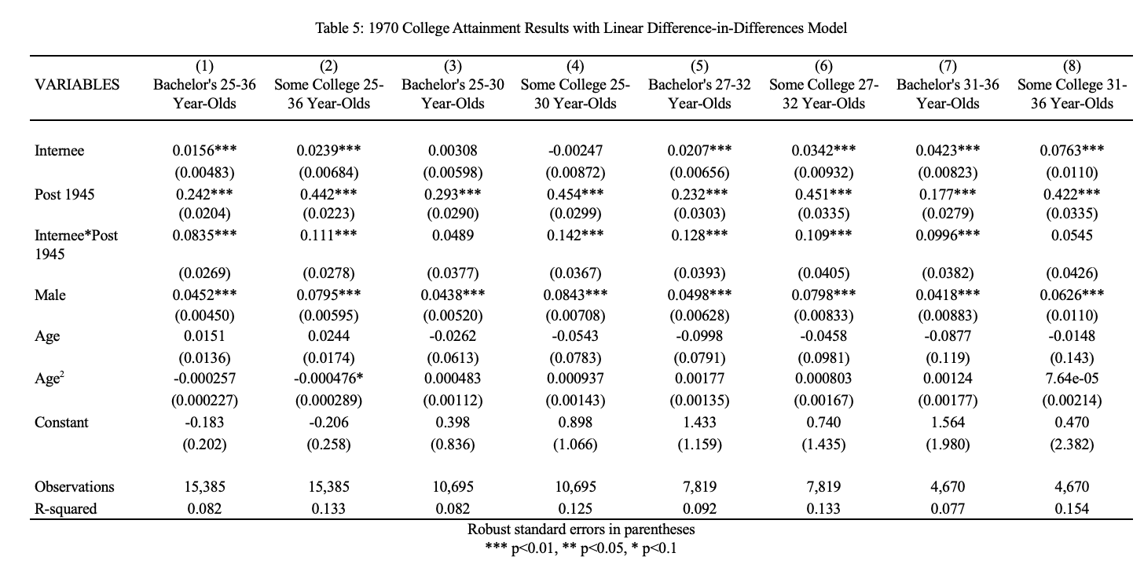

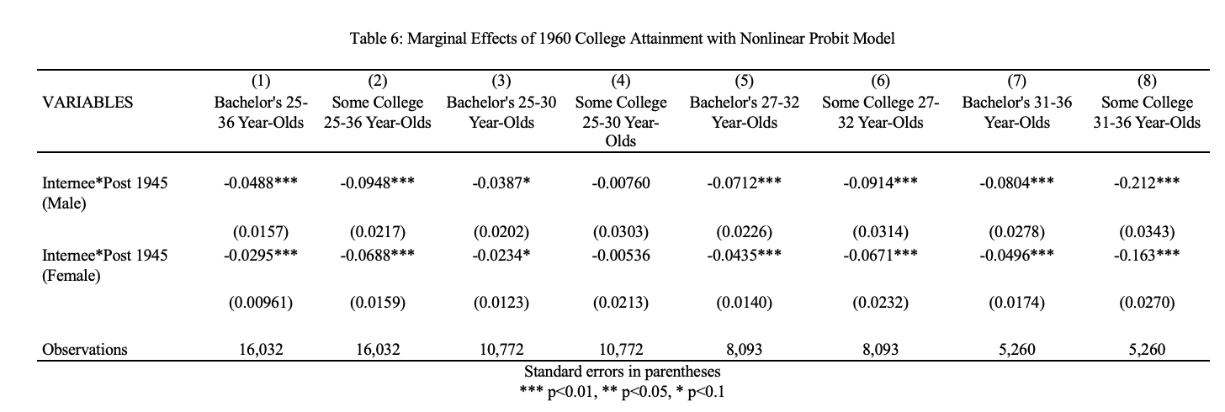

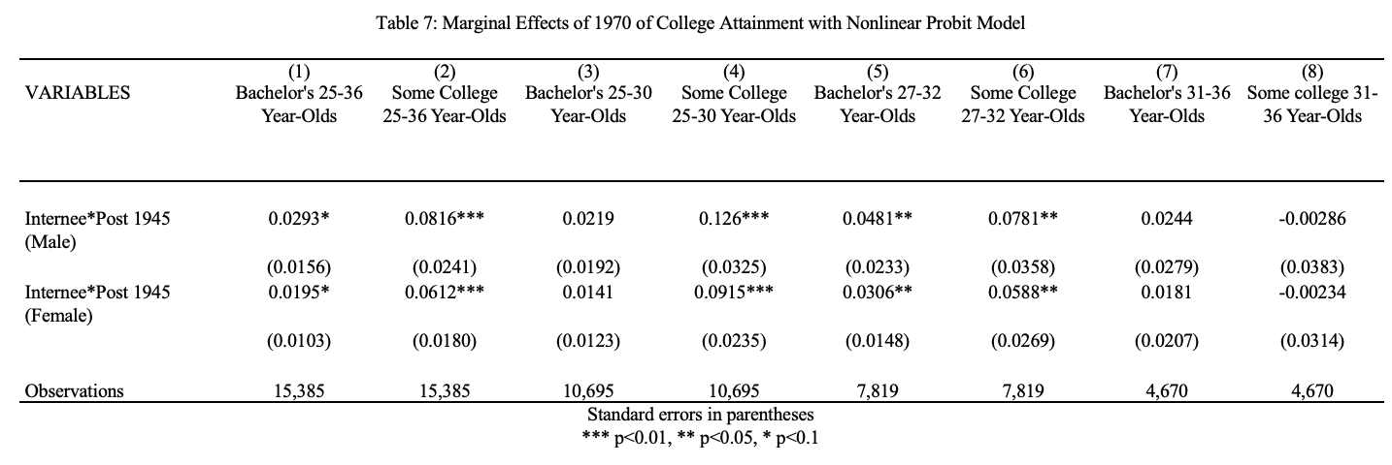

To better understand how internment interacted with age, I examine its effect on the subdivided younger, middle, and older age cohorts. Complimenting findings by Fugita and Fernandez (2004) and Nagata and Takeshita (1998) that suggest internment less adversely impacted younger internees, internment harmed 25-30 year-old internees’ (aged 10 to 15 in 1945) college decisions less than the older cohorts. In 1960, internment made them 6.49 percentage points less likely to earn a bachelor’s degree relative to the control (significant at the five percent level). Males experienced a 3.87 percentage point smaller increase in bachelor’s attainment, and females saw a 2.34 percentage point smaller increase relative to the control (significant at the 10 percent level). Despite internment’s impact on bachelor’s attainment, it had no statistically significant effect on this group’s ability to complete some college. Compared to the older cohorts, these internees had more time to recover from internment, potentially mitigating its impact on their college decisions and attainment.

While internment did not affect this cohort’s bachelor’s attainment in 1970, it positively impacted their attainment of some college at the one percent significance level. 25-30 year-old internees, released from the camps as zero to five year-olds, experienced a 14.2 percentage point larger increase in some college completion compared to the control. Specifically, males became 12.6 percentage points more likely to complete some college, and female internees became 9.15 percentage points more likely than the control. These internees had approximately 15 years to recover from interment before making their college decisions. While they became more likely to begin college, this did not lead to more earning bachelor’s degrees relative to the control group as one might expect.

Internment’s adverse impact on college attainment grows for the 27-32 year-old cohort (aged 12 to 17 in 1945) in 1960. Internment caused an 8.74 percentage point smaller increase in bachelor’s attainment compared to the control group–approximately a 3.4 percentage point smaller increase than the overall effect on 25-36 year-olds. Males became 7.12 percentage points, and females became 4.35 percentage points less likely to earn a bachelor’s degree compared to the control. Unlike the 25-30 year-olds, internment also impacted this group’s decision to start college. They experienced a 9.79 percentage point smaller increase in some college completion relative to the control. For males, internment caused them to become 9.14 percentage points less likely to attain some college relative to the control. This effect was comparatively smaller for females who experienced a 6.74 percentage point smaller increase relative to the control. These findings are all significant at the one percent level.

Interestingly, in 1970, this cohort’s college attainment experienced a larger positive impact from internment than the other cohorts. These internees are the only ones where both bachelor’s attainment and some college attainment are statistically significant. Released from the camps as two to seven year-olds, internees’ bachelor’s attainment experienced a 12.8 percentage point larger increase compared to the control (significant at the one percent level). Males became 4.81 percentage points more likely, and females became 3.06 percentage points more likely to earn a bachelor’s degree relative to the control (significant at the five percent level). Some college attainment increased by 10.9 percentage points relative to the control (significant at the one percent level). Internment led to a 7.81 percentage point larger increase in some college attainment for males, and a 5.88 percentage point larger increase for females relative to the control (significant at the five percent level).

Lastly, internment also greatly negatively impacted the oldest 31-36 year-old cohort. As measured in 1960, these internees entered the camps between ages 13 and 18 and were released as 16 to 21 year-olds. Internment, thus, likely directly disrupted many of their college decisions. Understandably, it caused a 5.46 percentage point smaller increase in bachelor’s attainment compared to the control (significant at the five percent level). Males experienced an 8.04 percentage point smaller increase, and females experienced a 4.96 percentage point smaller increase in bachelor’s attainment relative to the control (significant at the one percent level). Among all the age cohorts, internment most harmed this group’s attainment of some college, consistent with the literature discussed that found college-age internees experienced higher levels of stress from derailed educational and career plans. These internees became a full 19.3 percentage points less likely to complete some college than the control (significant at the one percent level). Male internees experienced a 21.2 percentage point smaller increase, and females saw a 16.3 percentage point smaller increase compared to the control (significant at the five percent level). While the WRA did release around 4,300 internees from the camps early to attend Midwestern and East Coast colleges, internment and anti-Japanese discrimination certainly complicated the decision to both attend and complete college as the results reflect.

In 1970, internees measured as 31-36 year-olds (aged six to 11 in 1945) experienced a 9.96 percentage point larger increase in bachelor’s degree attainment relative to the control (significant at the one percent level). (Bachelor’s degree attainment is not significant using the probit model’s results.) Interestingly, though, internment did not affect this group’s completion of some college as one might expect.

**Discussion:**

*1960:*

As measured in 1960, the drop in college attainment for internees across age cohorts relative to the control group is understandable. Many of those interned as teenagers and college-aged adults became their families’ primary income producers in the aftermath of internment (Nakadate 2013, 153). A government estimate found that West Coast Japanese lost 75 percent of their assets (Reeves 2015, 258), with one former internee testifying to the US Commission on Wartime Relocation and Internment of Civilians (US CWRIC) that it was “not uncommon” that almost every family member needed to work just to get by (US CWRIC 1983, 241). Thus, for many young adults, college attendance was no longer possible as their parents, often in their late 50s and 60s and impoverished, became dependent on them (US CWRIC1983, 295).

Additionally, the continued prevalence of anti-Japanese sentiment even after the war ended potentially contributed to hindering former internees’ economic and human capital recovery. Companies commonly told internees returning to the West Coast, “We don’t hire Japs” (US CWRIC 1983, 258). In an interview I conducted, one internee recounted how two separate Santa Ana, California public schools turned away him and his two brothers because they were Japanese (Tom Marumoto, Interview 1, November 12, 2023). Still, many others recalled struggling to find housing due to post-war shortages and discrimination causing families to live in single rooms, hotels, or churches (US CWRIC 1983, 241). Even when families could afford to buy a home, they faced restrictive covenants prohibiting them from moving in (US CWRIC 1983, 242).

Since education and wealth often correlate, I test the hypothesis that internment impacted the wealth of internees relative to the control group. As wealth is difficult to directly measure, I use homeownership rates as a proxy and run a linear difference-in-differences model with robust standard errors where:

*Homeownershipi,t= β0+β1Interneei+β2Postt+β3(Interneei*Postt)+β4Malei+β5Agei+β6Age2i+β7Yeart+ui,t*

Like college attainment, Homeownershipi,t is a binary variable that equals one if the individual owns a home. The Interneei, Postt, Interneei*Postt, Malei, Agei, Age2i, and Yeart variables are consistent with the previous college attainment regression. I also check for pre-internment homeownership parallel trends. Since the 1930 Census does ask about homeownership, I can directly test this by comparing the homeownership path of 25-36 year-old Japanese Americans with that of the 25-36 year-old non-Japanese Asian American control group before internment. I find that the parallel trends assumption does not hold for homeownership rates as the interaction term is positive and statistically significant.[9] This suggests that Japanese Americans would have been more likely to own a home than the control group had they not been interned. I additionally run a probit regression because homeownership is a binary dependent variable where:

*P(Y=1|X1, X2,...,X7) = Φ[β0+β1Interneei+β2Postt+β3(Interneei*Postt)+β4Malei+β5Agei+β6Age2i+β7Yeart+ui,t]*

Y=1 is the probability that an individual owns a home, and Y=0 if otherwise. Tables 8 and 9 show these regressions’ results.

The results from the linear model show that while 25-36 year-old overall internee homeownership rates did not change, the 25-30 year-old and 27-32 year-old cohorts did experience a smaller increase relative to the non-Japanese Asian American control group. Fifteen years after internment, these internee homeownership rates saw a 10 and 10.2 percentage point smaller increase relative to the control group, respectively (significant at the five and one percent levels, respectively). The probit model’s results are also significant for both age cohorts. Males and females experienced an almost equal marginal effect. Relative to the control group, male internees became between 8.42 (25-30 cohort) and 8.87 (27-32 cohort) percentage points less likely to own a home, and female internees became between 8.08 (25-30 cohort) and 8.84 (27-32 cohort) percentage points less likely to own a home. Consequently, the combination of rebuilding wealth from scratch and persistent discrimination potentially harmed former internees’ abilities to advance both through education and asset accumulation. Given that pre-internment trends showed Japanese Americans’ homeownership rates were growing faster relative to the control group, these results arguably underestimate internment’s impact on internee homeownership rates.

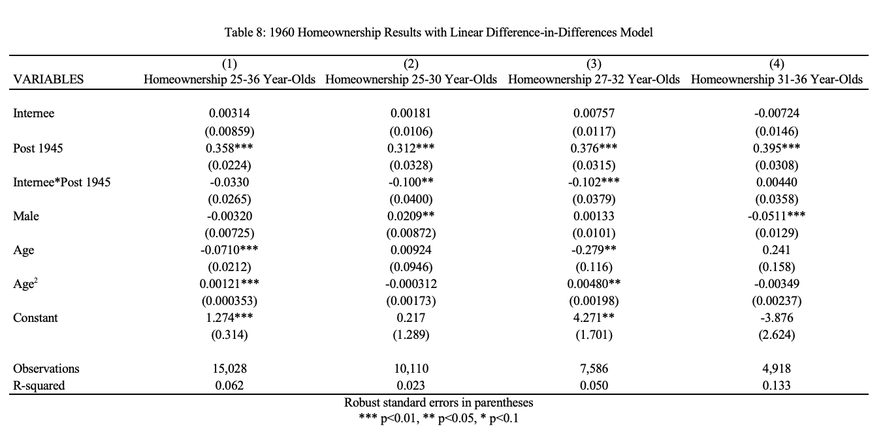

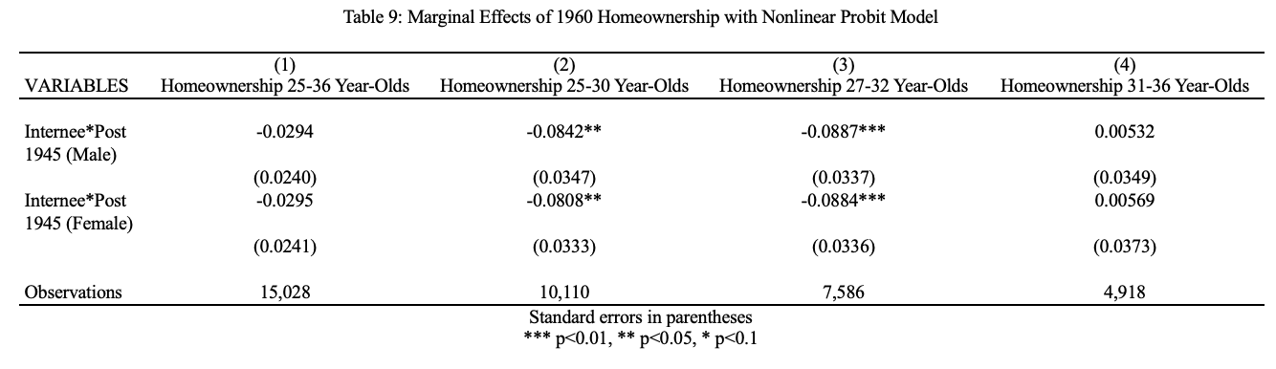

*1970:*

The finding that internment led to a larger increase in college attainment among internees compared to non-Japanese Asian Americans as measured in 1970 is initially surprising. Between 1960 and 1970, former internees not only fully recovered from internment’s negative economic impacts but became educated at rates even higher relative to the control group than in 1940. Throughout the 1950s and early 1960s (when those analyzed in 1970 were making their college decisions) attitudes toward Japanese Americans improved. Legal discrimination started to lessen. Congress passed the Immigration and Nationality Act of 1952 (also called the McCarran-Walter Act of 1952) allowing immigration from Asia to resume and Japanese immigrants to finally naturalize as American citizens. In politics, Daniel Inouye (D-HI) became the first Japanese American elected to Congress in 1963. *The New York Times Magazine* ran a feature piece calling formerly interned Japanese Americans and their children a “success story” introducing the “model minority” myth (Petersen 1966).[10] This label arguably arose from young internees and Japanese Americans born directly after the war working to meet internal family expectations and to overcome discrimination resulting from internment.

Between 1960 and 1970, internees rebuilt their wealth to levels where they were no less likely to own a home than non-Japanese Asian Americans as shown in Tables 10 and 11. While these results do not conclusively prove that younger internees chose to invest their reaccumulated wealth into education rather than into physical assets, they also do not exclude the possibility that increased economic stability contributed to higher rates of college attainment. To fully examine whether internees viewed education as a more reliable path toward advancement because it unlocked access to skilled jobs, I would need to test whether spending on homes decreased. This would indicate that the money saved from buying a cheaper home could instead be used to fund a college education. Unfortunately, the home value variable contained significant issues as it priced multiple homes at $1 and $9,999,998 which prevented me from confidently running this test. I also qualitatively explored this wealth reinvestment possibility by reading former internees’ accounts and conducting an interview to ensure consistency between my empirical results and their lived experiences.

Increasing college attainment through the potential reprioritization of wealth supports the emphasis some older internees placed on education as a better-protected form of security than property. One child of an internee noted that his father always said, “Get a good education, for it is something no one [can] take away from you” (US CWRIC 1983, 300). Another internee echoed this sentiment adding that his parents’ economic setbacks “caused them to value learning all the more” (Nakadate 2013, 158-159). Caudill and Mixon’s (2012) findings that human capital investments grow when physical capital is perceived as risky also support this transition by internees to increased investment in education.

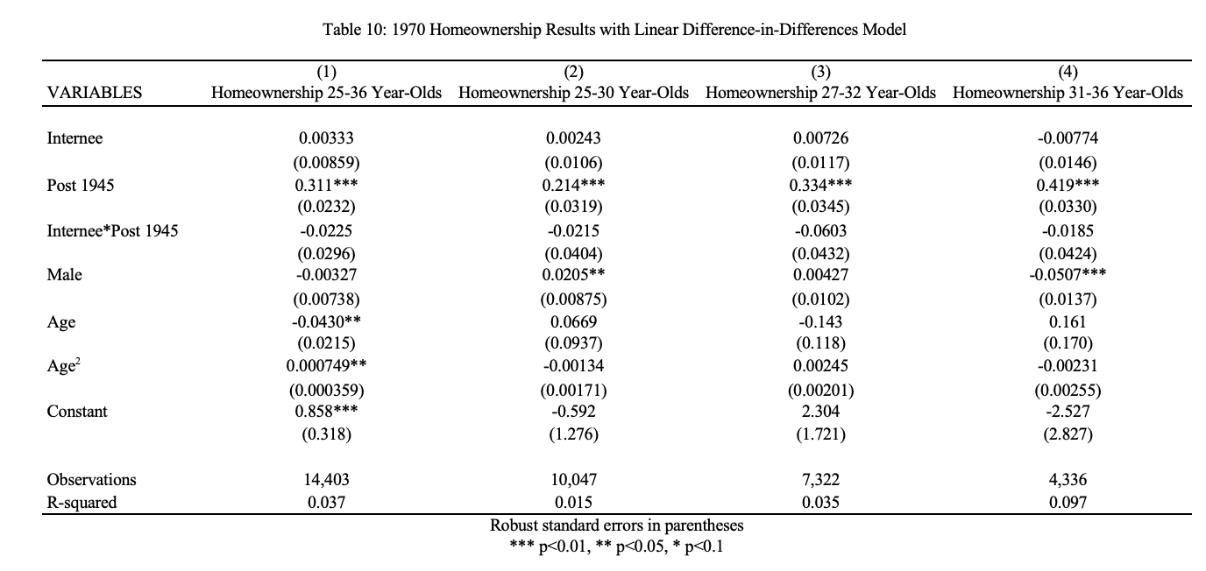

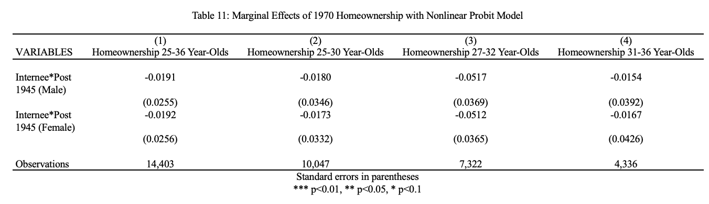

Qualitatively, while Japanese Americans culturally valued education as integral to long-term success dating back to the first Japanese immigrants to the United States (Nakadate 2013, 5), testimony from internees and those born directly after internment suggests that education became even more important post-internment. Older internees prioritized higher education for their children, many of whom the 1970 analyses on college attainment captured. As former internees battled anti-Japanese discrimination, high educational attainment and robust extracurriculars became paths to gain white Americans’ respect. Tom Marumoto, who was interned at Gila River from ages five to nine, recalled his father explaining to him that some people hated the Japanese because of the war. His father emphasized education, telling Marumoto that because of this prejudice getting Bs was not enough. He needed to outperform white students by getting As to make himself harder to overlook. Marumoto and his two brothers all went on to earn graduate degrees (Tom Marumoto, Interview 1, November 12, 2023).

Moreover, a college education became a way for younger internees and those born after internment to fulfill their families’ dreams. Internment and discriminatory laws permanently disrupted many of their parents’ educations and destroyed everything that their grandparents had spent years fighting to build for their children and grandchildren (Nakadate 2013, 156). Culturally, an emphasis on respect for elders and an awareness of how much their parents sacrificed for them, created additional impetus for the younger generation to take their education seriously (Nakadate 1998, 133; Tom Marumoto, Interview 1, November 12, 2023). While outsiders began labeling Japanese Americans as “overachievers” in school, many just wanted to live up to their parents’ expectations that they achieve their best (Nakadate 2013, 157). Marumoto explained that although coaching sports was his passion, he pursued pharmacy school and worked as a pharmacist because he did not want to let his parents down (Tom Marumoto, Interview 1, November 12, 2023). Tellingly, the 27-32 year-old and 31-36 year-old cohorts (aged two to 11 in 1945) experienced the largest increase in bachelor’s degree attainment in the 1970 results. As the oldest groups, they arguably best understood exactly how much their parents had sacrificed during internment and immediately afterward.

**Conclusion:**

At a time when America was fighting injustice abroad, Japanese internment stands as a reminder of the injustices perpetrated at home by wartime fear and prejudice. At best, the government and military leaders failed to prevent the stripping away of an entire ethnic group’s rights. At worst, they actively participated in this effort from General DeWitt’s pronouncements that “‘A Jap is a Jap!....There is no way to determine their loyalty’" (US CWRIC 1983, 221), to Assistant Secretary of War John McCloy asserting that the government could “cover [internment’s legality]…in spite of the Constitution” (McCloy-DeWitt telephone transcript, February 3, 1942), to the Supreme Court upholding the injustice in three separate cases (*Hirabayashi v. United States* (1943), *Yasui v. United States* (1943), *Korematsu v. United States* (1944)). Although it is easy to treat internment as an unfortunate footnote in an otherwise commendable period in American history, internment’s effects on the 120,313 Japanese interned did not end when the final camp closed in 1946 (WRA 1946, 1).

For those interned as older children, teenagers, and college-aged adults, internment prevented many of them from reaching their full potential. As the 1960 college attainment and homeownership results show, internees were still recovering relative to non-Japanese Asian Americans even 15 years after the war. This constitutes thousands of people whom the government denied the opportunity to become college-educated and work skilled jobs or become homeowners. Moreover, internees could not pass down the wealth they would have gained from these investments to younger generations, unlike their peers from other ethnic groups.

The 1970 findings ultimately provide a positive outcome for those interned at young ages who became more educated than the control group. Internment, though, clearly distorted their behavior as well, albeit in an apparently positive or “model” way. Would so many have prioritized going to college had they not believed it was a path to fulfill the dreams of older Japanese who were denied opportunities because of internment and discriminatory laws? Would so many have felt pressure to excel in their academics as a way to ensure white Americans could not overlook them or as a course to secure their futures from physical capital losses?

Given the connection between education and wealth, examining internment’s intergenerational legacy becomes the next step for future study. How did high educational attainment among young internees shape their children’s and grandchildren’s opportunities? Did the 1988 reparations impact intergenerational wealth outcomes? While Japanese internment was a gross civil rights violation, it should also underscore this country’s commitment to equality and individual freedoms. As Congressman and former internee Norman Mineta (CA-13) said when advocating for reparations, “Those of us who support this bill…want to make sure that such blatant constitutional violations never occur again” (Washington Post Staff 1987).

**Appendix:**

Figure A1: Map of Exclusion Zone and Japanese Internment Camps

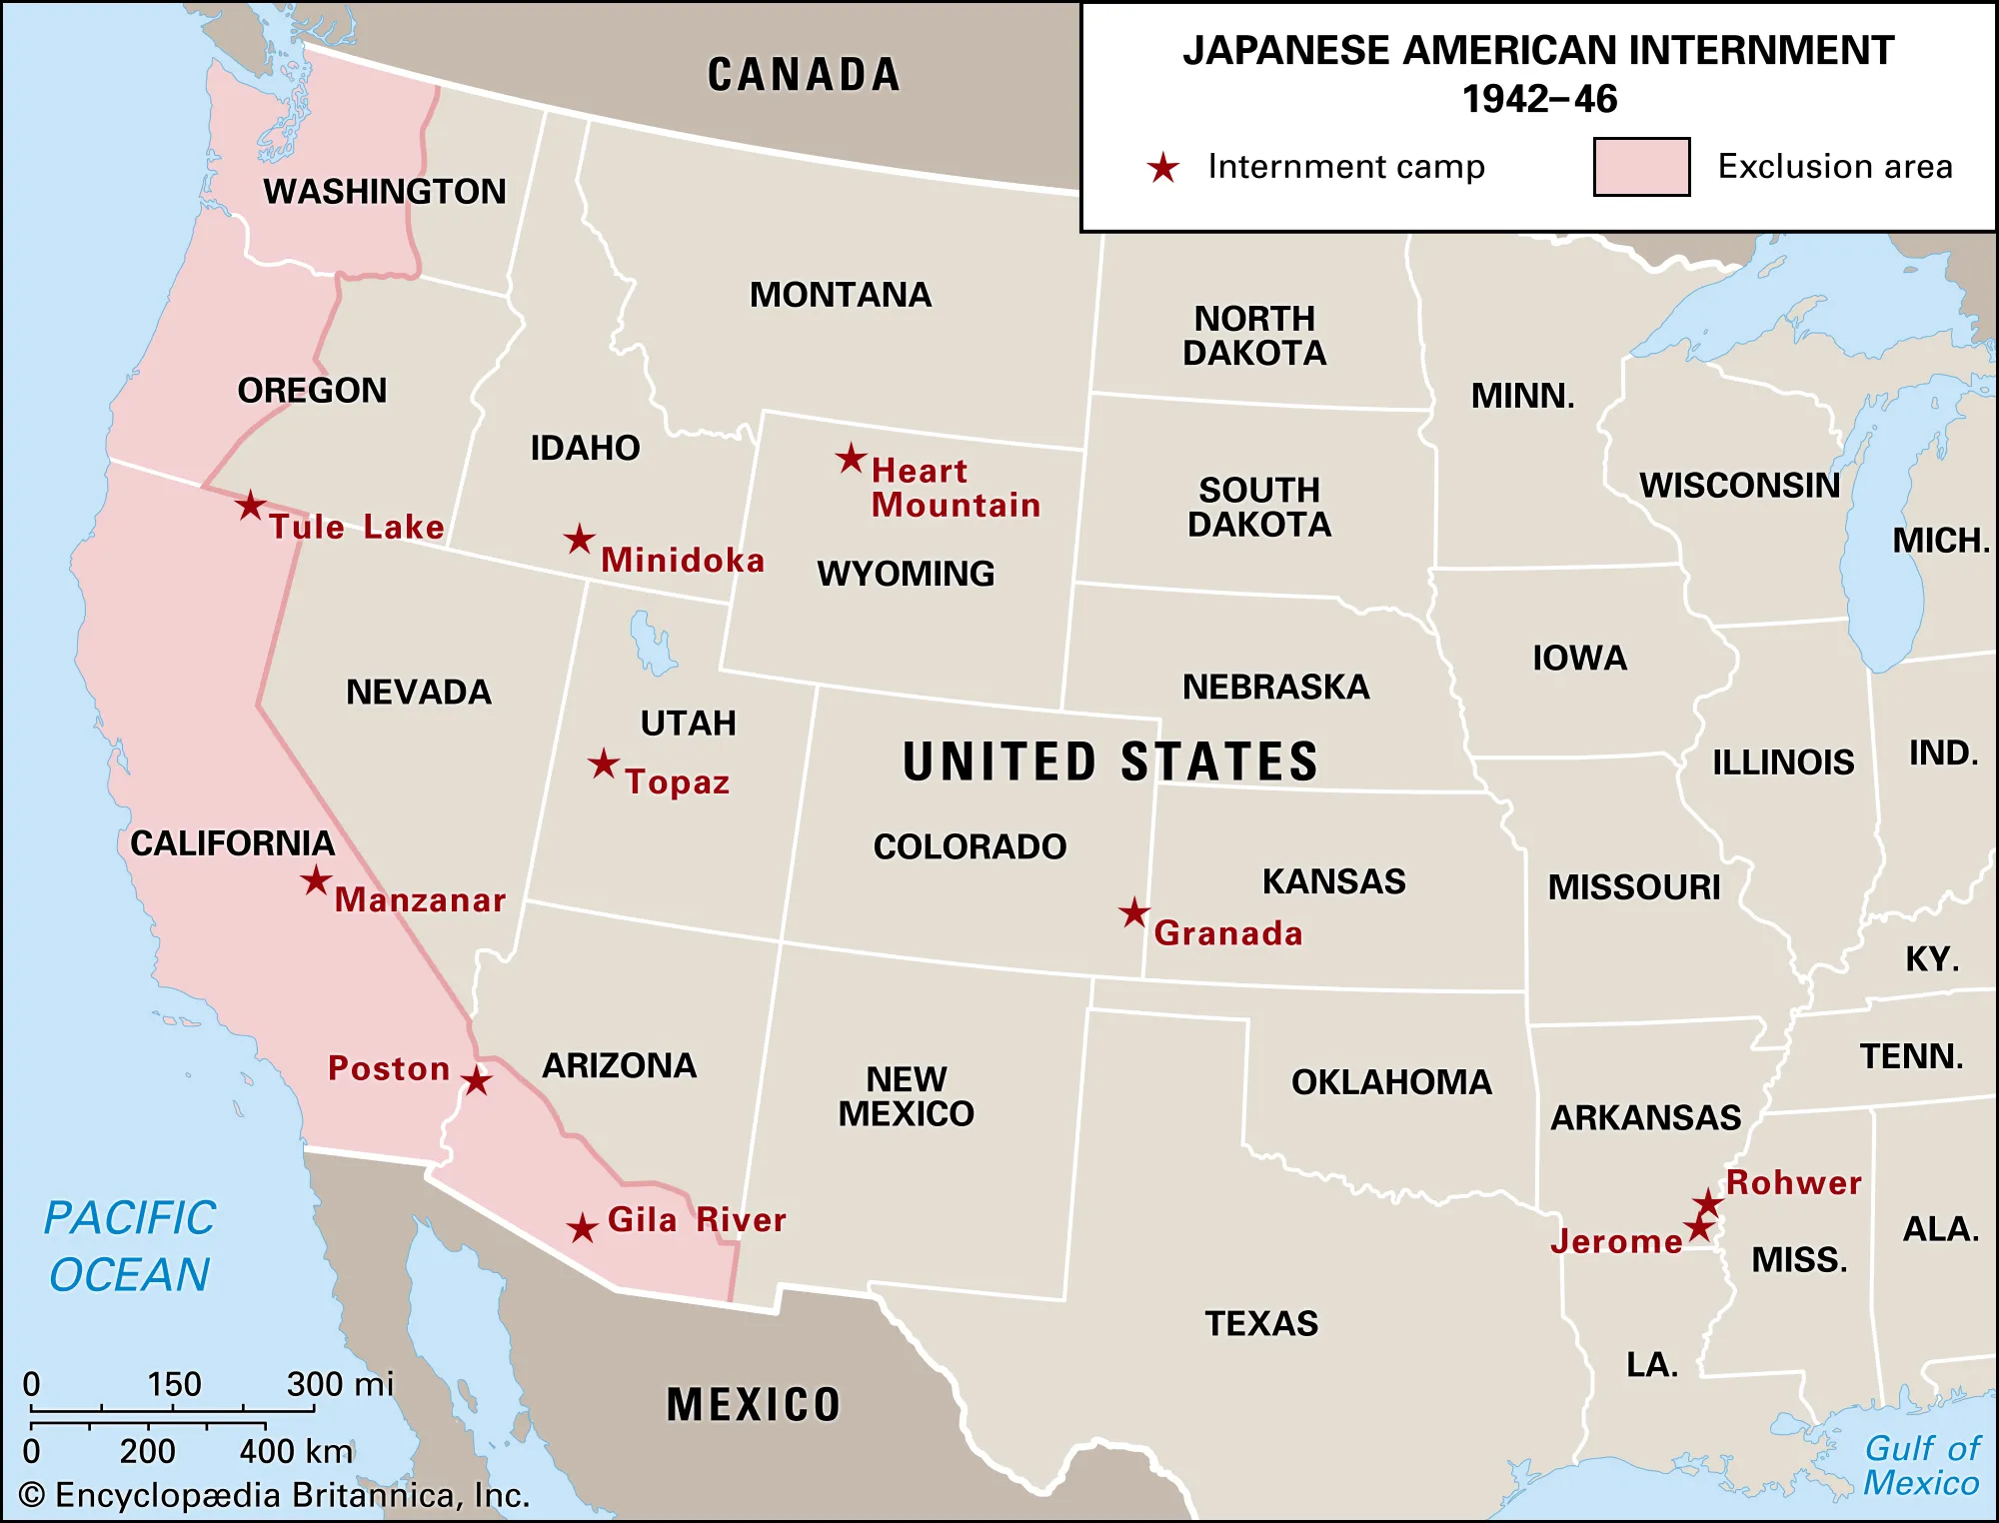

Source: “Japanese American internment camps,” *Britannica*, last modified November 10, 2023, accessed December 10, 2023, <https://www.britannica.com/event/Japanese-American-internment>.

Graph A1: College Attainment Rates for 25-36 Year-Olds Including 1950

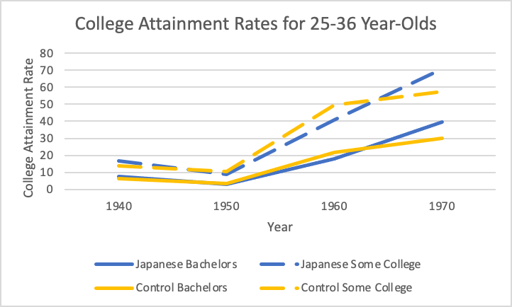

Graph A2: College Attainment Rates for 25-30 Year-Olds Including 1950

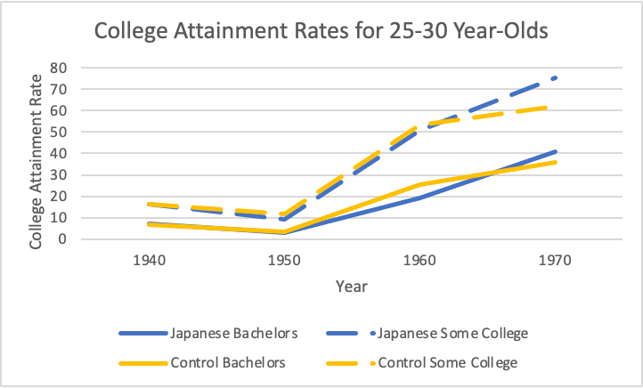

Graph A3: College Attainment Rates for 27-32 Year-Olds Including 1950

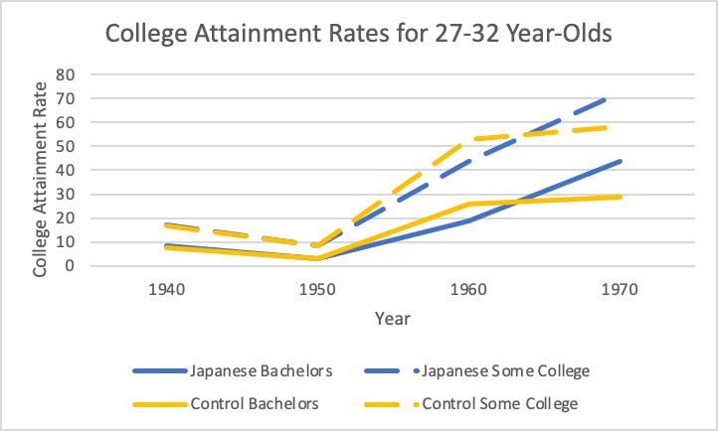

Graph A4: College Attainment Rates for 31-36 Year-Olds Including 1950

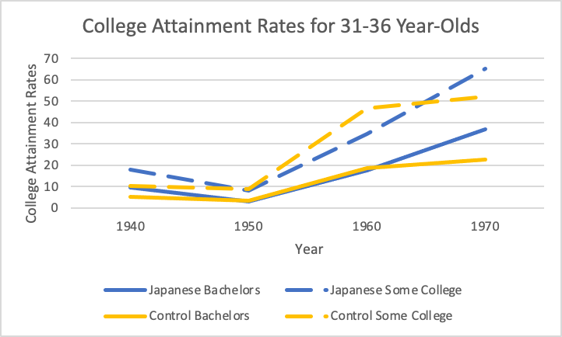

Equation A1: 1930-1940 Pre-Internment Homeownership Parallel Trends Model

*Homeownershipi,t= β0+β1Japanesei+β2Postt+β3(Japanesei*Postt)+β4Malei+β5Agei+β6Age2i+ui*

Table A1: 1930-1940 Pre-Internment Homeownership Parallel Trends Results

|  | (1) |
| --- | --- |
| VARIABLES | Homeownership |
|  |  |
| Japanese | -0.0381*** |
|  | (0.0132) |
| Post 1935 | 0.0394*** |
|  | (0.0109) |
| Japanese*Post 1935 | 0.0363** |
|  | (0.0156) |
| Male | 0.00300 |
|  | (0.00666) |
| Age | -0.0634*** |
|  | (0.0190) |
| Age2 | 0.00103*** |
|  | (0.000317) |
| Constant | 1.174*** |
|  | (0.283) |
|  |  |
| Observations | 17,103 |
| R-squared | 0.004 |

Robust standard errors in parentheses

*** p<0.01, ** p<0.05, * p<0.1

References:

Arellano-Bover, Jaime. 2021. “Displacement, Diversity, and Mobility: Career Impacts of Japanese American Internment.” *The Journal of Economic History* 82 (1): 126-174. [https://www.cambridge.org/core/journals/journal-of-economic-history/article/displacement-diversity-and-mobility-career-impacts-of-japanese-american-internment](https://www.cambridge.org/core/journals/journal-of-economic-history/article/displacement-diversity-and-mobility-career-impacts-of-japanese-american-internment/F63443DE6FA168C2D6708D31D91258AC)*.*

Caudill, Steven B., and Franklin G. Mixon Jr. 2012. “Human capital investment and the internment of Japanese Americans during WWII: A public choice approach.” *International Journal of Applied Economics* 9 (1): 1-14. <http://conferencenow.info/yhsing/applied-economics-journals/ARCHIVE/ijae/index_files/IJAE%20MARCH%202012CAUDILL%20MIXON%205-1-12%20FINAL%20VERSION%20JapAmer%20Human%20Capital%20blind.pdf>.

Chan, Jeremy. 2019. “Chinese American Responses to the Japanese American Internment and Incarceration.” *Hastings Race & Poverty Law Journal* 16 (2): 207-232. <https://heinonline.org/HOL/Page?handle=hein.journals/hasrapo16&div=12&g_sent=1&casa_token=&collection=journals>.

Chin, Aimee. 2005. “Long-run labor market effects of Japanese American internment during World War II on working-age male internees.” *Journal of Labor Economics* 23 (3): 491-525. <https://www.journals.uchicago.edu/doi/full/10.1086/430285>.

“Executive Order 9066 of February 19, 1942, Authorizing the Secretary of War to Prescribe Military Areas.” <https://www.archives.gov/milestone-documents/executive-order-9066#transcript>.

Fugita, Stephen S, and Marilyn Fernandez. 2004. *Altered Lives, Enduring Community: Japanese Americans Remember Their World War II Incarceration.* Seattle: University of Washington Press.

Grodzins, Mortin. 1949. *Americans betrayed*. Chicago: University of Chicago Press.

Hendron, Nathaniel, Sonya R. Porter, and Ben Sprung-Keyser. 2022. “New Data Tool and Research Show Where People Move as Young Adults.” *United States Census Bureau*, July 25, 2022. [https://www.census.gov/library/stories/2022/07/theres-no-place-like-home.html](https://www.census.gov/library/stories/2022/07/theres-no-place-like-home.html#:~:text=Nearly%20six%20in%2010%20young,little%20to%20change%20these%20patterns).

Jensen, Gwendolyn M. 1997. “The experience of injustice: Health consequences of the Japanese-American internment.” PhD diss. University of Colorado at Boulder.

Katcher, Leo. 1967. *Earl Warren: A Political Biography.* New York: McGraw-Hill Book Company.

Kurashige, Scott. 2020. “Model Minority.” *Densho Encyclopedia.* Last modified May 29, 2020. <https://encyclopedia.densho.org/Model%20minority>.

Lynch, Kristin S., and Margie E. Lachman. 2020. "The effects of lifetime trauma exposure on cognitive functioning in midlife." *Journal of Traumatic Stress* 33 (5): 773-782. <https://onlinelibrary.wiley.com/doi/full/10.1002/jts.22522>.

McCloy-DeWitt telephone transcript, February 3, 1942. ASW 014.311, EDC Exclusion Order Reports, box 6, RG 107, National Archives.

Marumoto, Tom. Interview 1. Personal Communication, November 12, 2023.

Munson, Curtis B. 1941. “Japanese on the West Coast,” attached to November 7, 1941 memo from John Franklin Carter to President Roosevelt.

Nagata, Donna K. 1990. “The Japanese American Internment: Exploring the Transgenerational Consequences of Traumatic Stress.” *Journal of Traumatic Stress* 3 (1): 47–69. doi:10.1002/jts.2490030105.

Nagata, Donna K. 1998. “Intergenerational Effects of the Japanese American Internment.”In *International Handbook of Multigenerational Legacies of Trauma,* edited by Yael Danieli, 125-139. New York: Plenum Press.

Nagata, Donna K., and Yuzuru J. Takeshita. 1998. “Coping and resilience across generations: Japanese Americans and the World War II internment.” *Psychoanalytic Review* 85 (4): 587-613. [https://www.proquest.com/docview/195036668/fulltextPDF](https://www.proquest.com/docview/195036668/fulltextPDF/33954FE309F74D3EPQ/1?accountid=11456&sourcetype=Scholarly%20Journals).

Nakadate, Neil. 2013. *Looking after Minidoka: An American Memoir.* Bloomington: Indiana University Press.

National Center for Education Statistics. 2015. “Rates of high school completion and bachelor's degree attainment among persons age 25 and over, by race/ethnicity and sex: Selected years, 1910 through 2015.” Accessed April 1, 2024. <https://nces.ed.gov/programs/digest/d15/tables/dt15_104.10.asp>.

Petersen, William. 1966. “Success Story, Japanese-American Style.” *The New York Times Magazine,* January 9, 1966. <https://www.nytimes.com/1966/01/09/archives/success-story-japaneseamerican-style-success-story-japaneseamerican.html>.

Reeves, Richard. 2015. *Infamy: The Shocking Story of the Japanese American Internment in World War II.* New York: Picador.

Ruggles, Steven, Catherine A. Fitch, Ronald Goeken, J. David Hacker, Matt A. Nelson, Evan Roberts, Megan Schouweiler, and Matthew Sobek. IPUMS Ancestry Full Count Data: Version 3.0 [Revision of (full sample sizes)]. Minneapolis, MN: IPUMS, 2021. <https://doi.org/10.18128/D014.V3.0>.

Ruggles, Steven, Sarah Flood, Matthew Sobek, Daniel Backman, Annie Chen, Grace Cooper, Stephanie Richards, Renae Rogers and Megan Schouweiler. IPUMS USA: Version 15.0 [Revision of (full sample sizes)]. Minneapolis, MN: IPUMS, 2024. <https://doi.org/10.18128/D010.V15.0>.

Saavedra, Martin. 2013. “Early Childhood Conditions and Mortality: Evidence from Japanese American Internment.” *Available at SSRN 1932111*: 1-38. <https://papers.ssrn.com/sol3/papers.cfm?abstract_id=1932111>.

Saavedra, Martin. 2015. “School quality and educational attainment: Japanese American internment as a natural experiment.” *Explorations in Economic History* 57 (July): 59-78. <https://www.sciencedirect.com/science/article/pii/S0014498315000145>*.*

Saavedra, Martin. 2021. “Kenji or Kenneth? Pearl Harbor and Japanese-American assimilation.” *Journal of Economic Behavior & Organization* 185 (May): 602-624. <https://www.sciencedirect.com/science/article/pii/S0167268121001086>.

Shoag, Daniel, and Nicholas Carollo. 2016. “The Causal Effect of Place: Evidence from Japanese-American Internment.” *HKS Working Paper No. 16-022*: 1-34. <https://papers.ssrn.com/sol3/papers.cfm?abstract_id=2798253>.

United States Bureau of the Census. 1970. “Educational Attainment: March 1970.” *Current Population Reports,* Series P-20, No. 207. Washington, DC: US Government Printing Office.

United States Commission on Wartime Relocation and Internment of Civilians. 1983. *Personal Justice Denied : Report of the Commission on Wartime Relocation and Internment of Civilians*. Washington, DC: US Government Printing Office.

United States Department of Labor. n.d. “History of Federal Minimum Wage Rates Under the Fair Labor Standards Act, 1938 - 2009.” Accessed December 10, 2023. <https://www.dol.gov/agencies/whd/minimum-wage/history/chart>.

Washington Post Staff. 1987. “Excerpts From Rep. Mineta’s Statement On Internment Of Japanese Americans.” *The Washington Post,* September 17, 1987. [https://www.washingtonpost.com/archive/politics/1987/09/18/excerpts-from-rep-minetas-statement-on-internment-of-japanese-americans](https://www.washingtonpost.com/archive/politics/1987/09/18/excerpts-from-rep-minetas-statement-on-internment-of-japanese-americans/12544471-c65b-4cb7-888f-6cb92d1593a7/).

*War and National Defense,* “Restitution for World War II Internment of Japanese-Americans and Aleuts,” *US Code 50* (1989), Ch. 52 § 4202(a).

War Relocation Authority. 1946. *The Evacuated People: A Quantitative Description.* Washington, DC: US Government Printing Office.

1. Tule Lake in California was the final camp to close on March 20, 1946. In reports compiled by the US government, it is often excluded because it was used to house internees considered potentially disloyal to the United States.
2. This is the same Earl Warren who later became the celebrated Supreme Court Chief Justice responsible for the *Brown v. Board of Education* decision in 1954.
3. The Munson Report, an FBI and Office of Naval Intelligence report on West Coast Japanese filed in the weeks before Pearl Harbor, concluded there was “no Japanese ‘problem’ on the Coast” and that there was “far more danger from Communists and people of the Bridges type on the Coast than there was from Japanese” (Munson 1941). Decades later, the United States Commission on Wartime Relocation and Internment of Civilians would find that there was “not a single documented act of espionage, sabotage or fifth column activity…committed by an American citizen of Japanese ancestry or by a resident Japanese alien on the West Coast” (US CWRIC 1983, 3).
4. Despite Hawaii’s geographical proximity to Japan, officials did not seriously consider interning Japanese Hawaiians because this would have crashed the local economy which relied on Japanese labor to run its fruit and sugar plantations (Reeves 2015, 29). Additionally, it would have been logistically difficult to remove 158,000 Japanese from Hawaii (Chin 2005, 496 note 8).
5. In the months before Pearl Harbor, the government surveilled and compiled lists of Japanese (mostly community leaders including priests, teachers, and civic organization heads) identified as “Suspect Enemy Aliens” by the FBI and Census Bureau (Reeves 2015, 3). Within 48 hours of the attack on Pearl Harbor, the FBI arrested and imprisoned 1,500 of these leaders without charges on suspicion they might be spies and saboteurs for Japan (Nagata 1990, 50; Reeves 2015, 3).
6. See Figure A1 in the appendix.
7. The federal minimum wage at the time was $0.30 per hour (US Department of Labor, n.d.). Assuming individuals work 40 hours per week, they would make $48 per month–2.5 to four times more than what internees were paid.
8. I use the 25-36 year-old age range because it allows me to measure people in both 1960 and 1970 who were interned but presumably had not started college yet. The oldest, the 36 year-olds measured in 1960, would have been 18 when internment began; while the youngest, the 25 year-olds measured in 1970, would have been born in 1945 right before internment ended. Therefore, I can be reasonably confident that this 25-36 year-old age range captures internees who had not made their college decisions before internment.
9. See Equation A1 and Table A1 in the appendix.
10. As the Civil Rights Movement gained momentum in the 1960s, the media and politicians cast Japanese Americans as a “model minority” in contrast to African Americans and other minorities fighting for racial equality (Kurashige 2020). The *New York Times Magazine* piece represents one of several pieces from this time period that helped create this stereotype. University of California sociologist William Petersen sought to portray Japanese Americans as a “better [minority group] than any other group in [American] society” who became accomplished by their “own almost totally unaided effort” (Petersen 1966). He argued that their hard work and avoidance of either the “self-defeating apathy or…hatred so all-consuming as to be self-destructive” that creates “problem minorities” led to their success (Petersen 1966). Thus, this stereotype originated as a divisive tool to undermine African Americans’ and other minorities’ struggle for equal rights.